Faculty of Computer & Information Sciences
. . . . . . . . . . . . .Department
Ain Shams University
TestMate
AI-Powered Test Generation, Bug Detection & Automated
Repair
June 2026

Faculty of Computer & Information Sciences
. . . . . . . . . . . . .Department
Ain Shams University
TestMate
AI-Powered Test Generation, Bug Detection & Automated
Repair
This documentation submitted as required for the degree of bachelors in Computer and Information Sciences.
By
୘୚ᆇڎ݁ڎۋب ؜ٴڎﺍܳأܹࡗࡲ ؜ٴڎﻩ2022170388
ڎᆇ୚୘ﺍݿఃఈﻡﺍᅵᆇڎ༟؇ﺩﻝ2022170057
صۏل؇ང๤ﺭݪ؇୘୚ᆇڎﺭ2022170489
ڎ٭ݿۏ۳؇ﺩ୘୚ᆇިﺩﺍﺩﻡ2022170113
ᅦᆇݠ༠؇ᄟᄴ୘୚ᆇڎ ؜ٴڎﺍܳި۱؇ﺏ2022170276
ڎ٭أݿঌॻ༟ﺇང๤ﺍﺀޗ۬୘୚ᆇިﺩ2022170600
Under Supervision of
[Supervisor 1]
[Supervisor Title],
. . . . . . . . . . . . .Department,
Faculty of Computer and Information Sciences,
Ain Shams University.
[Supervisor 2]
[Supervisor Title],
. . . . . . . . . . . . .Department,
Faculty of Computer and Information Sciences,
Ain Shams University.

[Supervisor 3]
[Supervisor Title],
. . . . . . . . . . . . .Department,
Faculty of Computer and Information Sciences,
Ain Shams University.
June 2026
2

Acknowledgements
[This is just an example, write it as you like.Thank whom you want in any order.]
All praise and thanks to ALLAH, who provided me the ability to complete this work.I hope to accept this work from me.
Iamgratefultomyparentsandmyfamilywhoarealwaysprovidinghelpandsupport throughout the whole years of study.I hope I can give that back to them.
I also offer my sincerest gratitude to my supervisors, Prof. Dr. …, Dr. … and T.A. … who have supported me throughout my thesis with their patience, knowledge and experience. Finally, I would thank my friends and all people who gave me support and encouragement.
i

Abstract
Writingthoroughsoftwaretestsandrepairingthedefectstheyexposeareamongthemost time-consuming, repetitive, and error-prone activities in software engineering.Manual test authoring is inconsistent across developers, rarely achieves high coverage of edge cases, and gives no guarantee that the resulting tests can expose faults;locating and fixing the defects those tests reveal adds yet further manual effort.The commercial AI assistants that could help with these tasks depend on paid cloud APIs and require uploading proprietary source code to remote servers.TestMate automates this quality-assurance lifecycle end to end, entirely on the developer’s own machine.
TestMateisanAI-powered,cross-platformElectrondesktopapplicationthat,givena softwareprojectandoptionallyitsrequirements,automatically(1)extractsandstructures requirements from an SRS document or a README, (2) generates high-quality unit tests for theproject’ssourcefiles,(3)detectsthebugsthosetestsexpose,and(4)repairsthefaulty code automatically.It is built on a single open-weights model, Qwen2.5-Coder-7B-Instruct, adaptedwithlightweightLoRAsupervisedfine-tuningandaugmentedwithathree-layer Retrieval-AugmentedGenerationpipelineandaself-correctinggenerate–run–fixloop.A novel Bug Exposure Score (BES) gates test quality before a test is accepted, and spectrum-based fault localization (SBFL) guides the automated repair.
Theprojectdemonstratesthatasmall,locally-runmodelrequiringnopaidcloudAPI can be made competitive through retrieval, quality gating, and iterative self-correction.On contamination-freebenchmarks,thereportedMBPP-onlydecontaminatedmodelachieves, on the external TestEval test-generation benchmark (210 programs, suite mode), 93.8% line coverageanda97.6%passrate,wellabovetheun-tunedbasemodel(78.9%/79.8%);an internal system-versus-base comparison on HumanEval corroborates this, roughly doubling test-generation pass@1 from 33.5% to 60.4% (a test-generation figure, not a code-generation leaderboard result).Automated program repair on HumanEvalFix improves from a 67.68% baselinetoa91.46%repairsuccessrate.Thisdocumentationpresentstheproject’sback-ground,architecture,implementation,andtesting,togetherwithitsconclusionsanddirec-tions for future work.
ii

CONTENTS
Contents
Acknowledgements i
Abstract ii
List of Figures vi
List of Tables vi
List of Abbreviations vii
1 Introduction 1
1.1 Problem Definition.............................. 1
1.2 Motivation ................................... 2
1.3 Objectives................................... 3
1.4 Time Plan................................... 3
1.5 Documentation Outline............................ 4
2 Background 5
2.1 Large Language Models for Source Code .................. 5
2.2 Parameter-Efficient Fine-Tuning with LoRA................. 6
2.3 Retrieval-Augmented Generation....................... 7
2.4 Automated Test Generation.......................... 9
2.5 Automated Program Repair.......................... 10
2.6 Spectrum-Based Fault Localisation...................... 12
2.7 Requirement Extraction and Traceability................... 12
2.8 Comparison with Related Systems...................... 13
2.9 Chapter Summary............................... 14
3 System Architecture 15
3.1 Architecture Overview............................ 15
3.2 Desktop Application Architecture (Electron)................. 16
3.3 The AI Engine ................................. 17
3.4 Component Design.............................. 18
3.5 The Three-Layer RAG Pipeline ........................ 19
iii

CONTENTS
4 | 3.6 | Data Flow................................... |  |  |  |  |  |  |  |  |  |  | 19
 | System Implementation |  |  |  |  |  |  |  |  |  |  |  | 21
 | 4.1 | Implementation Overview |  |  | .......................... |  |  |  |  |  |  |  | 21
 | 4.2 | Part A — Requirement Extraction...................... |  |  |  |  |  |  |  |  |  |  | 21
 | 4.2.1 |  | SRS-based Extraction |  |  | ........................ |  |  |  |  |  |  | 22
 | 4.2.2 |  | README-based Extraction..................... |  |  |  |  |  |  |  |  |  | 22
 | 4.2.3 |  | Pseudocode and Flowchart...................... |  |  |  |  |  |  |  |  |  | 22
 | 4.3 | Part B — Test Generation........................... |  |  |  |  |  |  |  |  |  |  | 23
 | 4.3.1 |  | The Generate–Run–Fix Loop |  |  |  |  |  | .................... |  |  |  | 23
 | 4.3.2 |  | Prompt Construction......................... |  |  |  |  |  |  |  |  |  | 23
 | 4.4 | The Three-Layer RAG Pipeline ........................ |  |  |  |  |  |  |  |  |  |  | 24
 | 4.4.1 |  | Layer 1 — General Testing Knowledge............... |  |  |  |  |  |  |  |  |  | 24
 | 4.4.2 |  | Layer 2 — Code-under-Test Context................. |  |  |  |  |  |  |  |  |  | 25
 | 4.4.3 |  | Layer 3 — Accumulated Test Examples............... |  |  |  |  |  |  |  |  |  | 25
 | 4.4.4 |  | Context Fusion............................ |  |  |  |  |  |  |  |  |  | 25
 | 4.5 | The Bug Exposure Score (BES) |  |  |  | ....................... |  |  |  |  |  |  | 25
 | 4.5.1 |  | Motivation | .............................. |  |  |  |  |  |  |  |  | 26
 | 4.5.2 |  | The Five Dimensions......................... |  |  |  |  |  |  |  |  |  | 26
 | 4.5.3 |  | Scoring Formula and Gating..................... |  |  |  |  |  |  |  |  |  | 26
 | 4.6 | Part C — Automated Program Repair |  |  |  |  |  |  |  | .................... |  |  | 27
 | 4.6.1 |  | Spectrum-based Fault Localization .................. |  |  |  |  |  |  |  |  |  | 27
 | 4.6.2 |  | Patch Generation........................... |  |  |  |  |  |  |  |  |  | 28
 | 4.6.3 |  | AST-safe Application and Validation |  |  |  |  |  |  |  | ................ |  | 28
 | 4.7 | LoRA Fine-Tuning.............................. |  |  |  |  |  |  |  |  |  |  | 28
 | 4.7.1 |  | Dataset and Decontamination |  |  |  |  |  |  | .................... |  |  | 28
 | 4.7.2 |  | Hyperparameters and Setup |  |  |  |  |  | ..................... |  |  |  | 30
 | 4.7.3 |  | Training Procedure.......................... |  |  |  |  |  |  |  |  |  | 30
 | 4.8 | Results and Discussion............................ |  |  |  |  |  |  |  |  |  |  | 31
 | 4.8.1 |  | Experimental Setup.......................... |  |  |  |  |  |  |  |  |  | 31
 | 4.8.2 |  | Test-Generation Results (TestEval) |  |  |  |  |  |  |  | ................. |  | 32
 | 4.8.3 |  | Three-Axis Evaluation:Why Coverage Alone Is Misleading.... |  |  |  |  |  |  |  |  |  | 33
 | 4.8.4 |  | Internal Corroboration on HumanEval................ |  |  |  |  |  |  |  |  |  | 33
 | 4.8.5 |  | Automated-Repair Results...................... |  |  |  |  |  |  |  |  |  | 34
 | 4.8.6 |  | System-Level Ablations |  |  |  | ....................... |  |  |  |  |  | 34
 | 4.8.7 |  | Per-Benchmark Summary |  |  |  |  | ...................... |  |  |  |  | 35
 | 4.8.8 |  | Worked Example:Repairing a Real Defect |  |  |  |  |  |  |  |  | ............. | 36
 | 4.8.9 |  | Threats to Validity |  | .......................... |  |  |  |  |  |  |  | 37
 | 4.8.10Discussion |  |  | .............................. |  |  |  |  |  |  |  |  | 37
iv

5 System Testing 39
5.1 Overview................................... 39
5.2 Installation and Setup............................. 39
5.3 The Home Screen............................... 39
5.4 Workflow Walkthrough............................ 40
5.4.1 Requirement Extraction (Part A)................... 40
5.4.2 Test Generation (Part B)....................... 42
5.4.3 Bug Detection ............................ 42
5.4.4 Automated Program Repair (Part C)................. 42
5.5 Discussion................................... 44
6 Conclusion and Future Work 45
6.1 Conclusion .................................. 45
6.2 Advantages and Disadvantages........................ 46
6.3 Future Work.................................. 46
Tools 48
References 49
List of Figures
3.1 High-Level System Architecture of TestMate ................ 16
3.2 Electron Process Model and IPC....................... 17
3.3 End-to-End Data Flow Through TestMate.................. 20
4.1 Part A Requirement-Extraction Pipeline................... 23
4.2 Part B Generate–Run–Fix Loop with the BES Quality Gate......... 23
4.3 Bug Exposure Score Computation and Gating Decision........... 27
4.4 Part C SBFL-Guided Repair Loop...................... 28
5.1 TestMate home screen with the four workflow entry cards ......... 40
5.2 Part A input panel with the mode selector and similarity threshold ..... 41
5.3 Completed Part A run:329 items classified as REQ vs. non-requirement on
a real SRS PDF................................ 41
5.4 Completed Part B test-generation run with the generated pytest test and metrics42
5.5 The Zero-Day Bugs view and bug-detection metrics interface........ 43
v

5.6 | Completed Part C repair:bug fixed in one attempt, all tests passing after the | 43
 | patch ......................................
5.7 | Part C diff view: the corrected discount-calculation logic (red removed, green | 44
 | added).....................................
List of Tables
2.1 The three retrieval layers of the TestMate RAG pipeline. .......... 8
2.2 Comparison of TestMate with related automated testing and repair systems. 13
4.1 LoRA supervised fine-tuning configuration (reported test-generation model) 30
4.2 Headline test-generation results on TestEval (210 LeetCode programs, suite/coverage
mode):base model vs. TestMate....................... 32
4.3 The same TestMate system on the same TestEval benchmark under two ob-
jectives:a single coverage number is objective-dependent .......... 33
4.4 InternalcorroborationonHumanEval(TestMatevs.thesamebasemodel,
N= 164).These are test-generation figures and are not comparable to code-
4.5 | generation leaderboards. | ........................... |  | 34
 | Automated program repair on 164 HumanEvalFix bugs........... |  |  | 34
4.6 | System-level ablations:effect of LoRA fine-tuning and of RAG |  | ...... | 35
4.7 | Per-benchmark summary of the evaluation.................. |  |  | 36
vi

List of Abbreviations
Abbreviation | Meaning

AI  API  APR  AST  BES  BF16  BiLSTM BM25  CI  CRF  CSS  CUDA  DOCX  FAISS  FIM  FP16  GA  GPU  HTTP  IDE  IPC  LLM  LM  LoRA  MBPP  NF4  NLP  PDF  PEFT  PURE  QA  QLoRA | Artificial Intelligence  Application Programming Interface  Automated Program Repair  Abstract Syntax Tree  Bug Exposure Score  16-bit Brain Floating-Point (bfloat16)  Bidirectional Long Short-Term Memory  Best-Match 25 (Okapi BM25 ranking function)  Continuous Integration  Conditional Random Field  Cascading Style Sheets  Compute Unified Device Architecture  Microsoft Word document format  Facebook AI Similarity Search  Fill-In-the-Middle  16-bit (Half-Precision) Floating-Point  Genetic Algorithm  Graphics Processing Unit  HyperText Transfer Protocol  Integrated Development Environment  Inter-Process Communication  Large Language Model  Language Model  Low-Rank Adaptation  Mostly Basic Python Problems  4-bit NormalFloat (quantization type)  Natural Language Processing  Portable Document Format  Parameter-Efficient Fine-Tuning  Public dataset of requirements documents (Part A reference corpus) Quality Assurance  Quantized Low-Rank Adaptation
vii

LIST OF TABLES
Abbreviation | Meaning
RAG  REQ  REST  RLHF  SBFL  SBST  SDPA  SRS  SSE  SVM  TF-IDF  UI  URL  VRAM | Retrieval-Augmented Generation  Requirement (Part A classification label)  Representational State Transfer  Reinforcement Learning from Human Feedback Spectrum-Based Fault Localization  Search-Based Software Testing  Scaled Dot-Product Attention  Software Requirements Specification  Server-Sent Events  Support Vector Machine  Term Frequency–Inverse Document Frequency User Interface  Uniform Resource Locator  Video Random-Access Memory (GPU memory)
viii

Chapter 1
Introduction
Softwaresystemshavegrownenormouslyinscaleandcomplexity,andwiththatgrowth thecostofensuringtheircorrectnesshasrisensharply.Amongallsoftware-engineering activities, two of the most demanding are writing tests that genuinely exercise a program and repairing the defects those tests reveal.Both tasks are repetitive, require deep understanding of the code under examination, and consume a disproportionate share of development time. TestMateisagraduationprojectthataddressesthischallengedirectly:itisanartificial-intelligence-powereddesktopapplicationthatautomatesthesoftware-qualitylifecycleend toend,takingaprojectfromitsrequirementsthroughautomaticallygeneratedtests,bug detection, and finally automated repair of the faulty code.
1.1 Problem Definition
Modern software development relies heavily on automated testing to guarantee correctness, yet the creation of effective tests remains a largely manual effort.Developers must read and understand each function, reason about its expected behaviour, identify edge and boundary conditions, and then express all of this as concrete test cases.This process is slow, inconsis-tent between individuals, and offers no assurance that the resulting tests can actually expose faults.When a test does fail,the developer must then localize the defect within the source code and craft a correction, adding yet another layer of manual labour.The core problem this project tackles can be stated as follows:
•Manual test writing is time-consuming and inconsistent, and the quality of the produced tests depends entirely on the individual developer’s experience and diligence.
•Existingtestsfrequentlyachievelowcodecoverageandmisscriticaledgecases,al- lowing defects to escape into production.
•Locating and repairing detected bugs is a separate, equally manual activity that inter- rupts development and is prone to introducing new errors.
•Commercial AI coding assistants that could help typically depend on paid cloud APIs, raising concerns over cost, privacy, and transmitting proprietary source code to third-party servers.
1

CHAPTER 1.INTRODUCTION
TestMate addresses all four points by performing requirement extraction, test generation, bug detection, and automated repair locally on the developer’s own machine, using a single open-weights language model rather than a paid external service.
History
Automated software testing has evolved through several generations.Early approaches re-lied on random and search-based test generation (e.g. Randoop, EvoSuite), which maximized structural coverage but produced tests that were hard to read and rarely captured intended se-mantics.In parallel, automated program repair (APR) emerged, beginning with generate-and-validate systems like GenProg that mutated code and validated candidates against a test suite;spectrum-based fault localization (Ochiai, Tarantula) became the standard means of ranking suspicious locations.The arrival of large language models (LLMs) trained on code — Codex, CodeLlama, the Qwen2.5-Coder family — marked a turning point, enabling human-readable tests and semantically meaningful patches.More recently, Retrieval-Augmented Generation (RAG) has grounded model output in relevant context, while parameter-efficient fine-tuning such as Low-Rank Adaptation (LoRA) has made specializing large models feasible on mod-est hardware.TestMate builds on this lineage, uniting LLM-based test generation, retrieval augmentation, quality gating, and spectrum-based repair into one integrated system.
Applications
A system that automatically generates tests, detects defects, and repairs code has broad value:
•Software development teams can bootstrap test suites for legacy or under-tested code- bases.
•QAandtestengineerscanusetheBugExposureScoreandbug-detectionoraclesto prioritize modules needing human attention.
•Continuous-integration pipelines can catch and fix regressions earlier.
•Students and educators can study generated tests and repairs as executable examples.
•Privacy-sensitive organizations benefit from fully local, offline operation.
1.2 Motivation
The motivation behind TestMate stems from a clear gap between what modern AI models can do and what is actually available to everyday developers.Powerful proprietary assistants can write tests and fix bugs, but they require continuous internet access, incur per-request costs, anddemandthatpotentiallyconfidentialcodebeuploadedtoremoteservers.Atthesame
2

CHAPTER 1.INTRODUCTION
time, open-weights code models such as Qwen2.5-Coder have become small enough to run on a single consumer GPU, yet on their own they fall short of the accuracy needed for dependable test generation and repair.We were motivated by the question of whether a small,locally-runmodelcouldbemadecompetitivewithfarlargersystemsthroughcarefulengineering rather than sheer scale.By combining lightweight LoRA fine-tuning, a multi-layer retrieval-augmented context pipeline,a quantitative test-quality gate,and a self-correcting generate-run-fixloop,TestMatedemonstratesthatthisispossible—deliveringprofessional-grade automated testing and repair that is free to run, respects privacy, and works entirely offline.
1.3 Objectives
The principal objectives of the TestMate project are the following:
•To design and implement an end-to-end automated quality-assurance pipeline that ex-tracts requirements, generates unit tests, detects bugs, and repairs faulty code within a single application.
•To build the system around a single open-weights language model (Qwen2.5-Coder- 7B-Instruct) that runs entirely locally, requiring no paid external API.
•To make the small model competitive through parameter-efficient LoRA fine-tuning, a three-layer Retrieval-Augmented Generation pipeline, and a self-correcting iterative loop.
•To introduce a Bug Exposure Score (BES) that quantitatively gates the quality of every generated test before it is accepted.
•Toimplementspectrum-basedfaultlocalization(SBFL)andAST-safepatchingfor reliable automated program repair.
•To deliver the entire system as a cross-platform desktop application with an intuitive interface, accessible to developers without specialist machine-learning knowledge.
•To evaluate the system rigorously on contamination-free public benchmarks and demon- strate measurable improvements over the un-tuned baseline model.
1.4 Time Plan
Theprojectwascarriedoutoveranacademicyear,fromSeptember2025toJune2026. Work was organized into nine overlapping phases, progressing from initial research and re-quirement extraction, through the development of the three core components (test generation, fine-tuning with retrieval, and automated repair), to system integration, evaluation, and final documentation.The Gantt chart in Figure 1.1 summarizes the schedule.
3

CHAPTER 1.INTRODUCTION

1.Research & Requirement Extraction (Part A) 2.Dataset Preparation & Decontamination
3.Test Generation Engine (Part B)
4.LoRA Fine-Tuning & RAG Layers
5.Automated Program Repair (Part C)
6.System Integration (Unified Desktop App) 7.Evaluation & Benchmarking
8.Testing & Refinement
9.Documentation & Final Submission

Sep | Oct | Nov | Dec | Jan | Feb | Mar | Apr | May | Jun

Figure 1.1:TestMate Project Time Plan (Gantt Chart)
1.5 Documentation Outline
The remainder of this documentation is organized into five further chapters, followed by the tools used and the list of references.
•Chapter 2 (Background) presents the literature review and related work, the theoreti-cal background, and the algorithms and techniques on which TestMate is built — large language models, LoRA fine-tuning, Retrieval-Augmented Generation, and spectrum-based fault localization.
•Chapter3(SystemArchitecture)describestheoverallarchitecture,itsmaincom-ponents,thedesktopapplication’sprocessmodel,andtheflowofdatathroughthe requirement-extraction, test-generation, and repair stages.
•Chapter4(SystemImplementation)explainsthedetailedimplementationofeach component—PartA(requirementextraction),PartB(testgeneration),PartC(au-tomated program repair) — using flowcharts and pseudocode, and reports results and discussion for each.
•Chapter 5 (System Testing) explains how the application is installed, run, and used, illustrated with screenshots of the complete workflow.
•Chapter 6 (Conclusion and Future Work) summarizes the project, states its advan- tages and disadvantages, and outlines directions for future development.
The documentation concludes with a Tools section listing the hardware and software used, and a References section citing the books, papers, and online resources consulted.
4

Chapter 2
Background
Thischapterprovidesthetheoreticalfoundationandrelated-worksurveythatunderpinthe design of TestMate.It begins by reviewing the evolution of large language models applied to source code, then examines the parameter-efficient fine-tuning technique known as Low-RankAdaptation(LoRA)thatmakesspecialisationofthesemodelspracticalonconsumer hardware.The chapter continues with an account of Retrieval-Augmented Generation (RAG) and the specific multi-layer variant adopted in TestMate, followed by a survey of automated test-generation methods ranging from classical search-based approaches to the most recent LLM-drivensystems.AutomatedProgramRepair(APR)andspectrum-basedfaultlocali-sationarethencovered,astheyformthebackboneofTestMate’sPartCsubsystem.The chapter closes with a structured comparison of related tools and a statement of the gaps that TestMate addresses.
2.1 Large Language Models for Source Code
Thedeploymentoflargelanguagemodels(LLMs)trainedonprogramminglanguageshas transformed the field of software engineering automation.The trajectory begins with OpenAI Codex[1],a12-billion-parametermodeltrainedon159GBofpubliclyavailableGitHub code.Codex demonstrated, for the first time at scale, that a neural language model could solve competitiveprogrammingproblemsandgeneratesyntacticallycorrect,oftensemantically meaningfulPythonfromnatural-languagedocstrings.ItspublicinterfacethroughGitHub Copilot brought AI-assisted coding to millions of developers.
Meta subsequently released the CodeLlama family [2], derived from the general-purpose LLaMA 2 architecture and further trained on 500 billion tokens of code-heavy data.CodeL-lama introduced a fill-in-the-middle (FIM) objective that allows the model to complete code given both preceding and following context, a capability well-suited to IDE auto-completion scenarios.Concurrently, DeepSeek-Coder [3] showed that a model trained from scratch on 2trilliontokens—87%code,13%naturallanguage—witha16kcontextwindowcould outperform all prior open models of the same size on HumanEval and MBPP benchmarks.
ThemodelattheheartofTestMateisQwen2.5-Coder-7B-Instruct[4],releasedbyAl-ibaba DAMO Academy.Trained on 5.5 trillion tokens that span 92 programming languages with a deliberate mixture of code, code-related text, and mathematics, Qwen2.5-Coder achieves
5

CHAPTER 2.BACKGROUND
state-of-the-art performance on HumanEval, MBPP, and MultiPL-E at the 7-billion-parameter scale.Crucially, the Instruct variant has been aligned through supervised fine-tuning and re-inforcement learning from human feedback (RLHF) to follow natural-language instructions, making it directly usable as a test-generation agent without additional instruction-tuning of thebasemodel.The7-billion-parametersizeallowsthemodeltobeloadedin4-bitNF4 quantisationintoapproximately5GBofGPUmemory,fittingcomfortablyonaconsumer RTX 4060 with 8 GB of VRAM.
Quantisation and On-Device Inference
Runninga7-billion-parametermodellocallyrequiresaggressivememoryreduction.Bit-sAndBytes (Dettmers et al., 2022) provides a practical solution through NF4 4-bit quantisa-tion,whichrepresentseachweightusinga4-bitnormal-floatformatdesignedtominimise the information loss for Gaussian-distributed neural network weights.Combined with double quantisation — which itself quantises the quantisation constants — NF4 reduces the effective memoryfootprintofQwen2.5-Coder-7Bfromapproximately14GB(inBF16)toroughly 4.5 GB, enabling inference on a single consumer GPU. TestMate loads the model with this configuration at startup and keeps it resident in VRAM for the duration of the test-generation session.
Attentionefficiencyisasecondaxisofoptimisation.TestMateusesPyTorch’sScaled Dot-ProductAttention(SDPA)backend,whichselectsthemostmemory-efficientkernel (FlashAttention-2 when available, otherwise a memory-efficient variant) automatically.On the RTX 4060, this provides approximately a 1.3× throughput improvement over the naive eager attention implementation with no additional VRAM cost.
2.2 Parameter-Efficient Fine-Tuning with LoRA
Full fine-tuning of a 7-billion-parameter model requires storing and updating every weight in the model, demanding tens of gigabytes of GPU memory even with gradient checkpointing. Low-RankAdaptation(LoRA),introducedbyHuetal.[5],offersanelegantalternative: rather than updating the original weight matrix W∈Rd×k, LoRA freezes Wand introduces two trainable low-rank matrices A ∈Rd×rand B∈Rr×kwith r≪min(d, k).The adapted weight at inference is simply
W+ ∆W= W+ BA. (2.1)
Because r is small — typically 4 to 64 — the number of trainable parameters is reduced by several orders of magnitude relative to full fine-tuning,and the original weights remain unchanged.
6

CHAPTER 2.BACKGROUND
Inthecontextofcodemodels,LoRAhasbeenshowntobehighlyeffectivefortask-specificadaptation.ThePEFTlibrary[6]providesaproduction-qualityimplementation that integrates seamlessly with the HuggingFace Transformers ecosystem.TestMate applies LoRAtothequery,key,value,andoutputprojectionmatricesofeveryattentionlayerin Qwen2.5-Coder-7B, using rank r=16 and scaling factor α=32.This configuration adds approximately 40 million trainable parameters — less than 0.6% of the base model — while yielding measurable improvements in test-generation correctness over the untuned base.
QLoRA Training on Consumer Hardware
QLoRA [7] combines 4-bit NF4 quantisation of the frozen base model with LoRA fine-tuning of the adapter weights in 16-bit precision.This combination means that only the small adapter matrices need to be updated in full precision, while the enormous frozen backbone is stored in4-bitformat.TestMate’strainingpipelineusesQLoRAwiththeSFTTrainerfromthe TRL library on the Kaggle T4 free-tier GPU, training for two epochs on 970 decontaminated MBPP samples.The resulting adapter is a small directory of SafeTensors files (approximately 80 MB) that can be loaded and hot-swapped in milliseconds on top of the resident base model.
Contamination control is a critical concern in benchmark evaluation.TestMate’s adapter is trained exclusively on the MBPP dataset [8] after removing all problems that overlap with theHumanEvalandTestEvalevaluationsets.Thisdecontaminationstep,implementedin thedecontaminate_mbpp.pyscript,ensuresthattheobservedevaluationgainsrepresent genuine generalisation rather than memorisation of the test set.
2.3 Retrieval-Augmented Generation
Retrieval-Augmented Generation (RAG), formalised by Lewis et al. [9], addresses a funda-mentallimitationofpurelanguage-modelgeneration:themodel’sknowledgeisfrozenat trainingtimeandcannotincorporateinformationaboutthespecificcodebasebeingtested. RAG augments the generation prompt with passages retrieved from an external corpus,al-lowing the model to ground its output in relevant and up-to-date information without retrain-ing.
In the code domain, RAG has been applied in several forms.RAGFix (Zhang et al., 2025) demonstrated that retrieving similar bug-fix patches from a historical database substantially improves the quality of LLM-generated repairs.KGCompass [10] proposed using a knowl-edge graph of the repository’s call relationships to navigate to the most relevant context for a given query.RAG Traceability (Guo et al., 2025) applied retrieval to link requirements to the code that implements them, enabling requirement-level test coverage analysis.
7

CHAPTER 2.BACKGROUND
TestMate’s Three-Layer RAG Architecture
TestMateextendsstandardsingle-corpusRAGintoathree-layerretrievalhierarchy,where each layer targets a different type of knowledge and uses an appropriate retrieval mechanism:
Table 2.1:The three retrieval layers of the TestMate RAG pipeline.
Layer | Retrieval Method | Content and Purpose
Layer 1 — External | FAISS vector search | TestingAPIdocumentation,frameworkusage
Docs |  | examplesretrievedfromanofflineFAISSin-
dex of curated external documents.
Layer2—Code | BM25 | + | semantic | Repositorycallgraph:calleefunctions,class
Graph | graph (KGCompass) |  |  | hierarchies,andcross-filedependenciesre-
trievedviaBM25keywordmatchingaug-
mented by semantic embedding similarity over
the code graph.
Layer3—RAG | SQLite+sentence- | Persistentmemoryofpreviouslyaccepted
Memory | transformers | high-quality test examples and failure patterns,
storedinanSQLitedatabaseandretrieved
by | embedding | similarity | using | sentence-
transformers.
Thislayereddesignensuresthatthegenerationpromptisgroundedsimultaneouslyin general testing knowledge (Layer 1), in the specific structure of the code under test (Layer 2), and in the system’s own accumulated experience of what constitutes a high-quality test for this codebase (Layer 3).The combined context is injected into the generation prompt before each LLM call, providing richer grounding than any single retrieval source could offer.
FAISS and Embedding-Based Retrieval
Thefirstandthirdretrievallayersrelyondensevectorretrieval.Eachdocumentorstored test example is encoded into a fixed-dimensional embedding vector by a sentence-transformer model [11].At query time, the target function’s source code is similarly encoded and the k nearest neighbours in embedding space are retrieved using a FAISS index [12].FAISS pro-vides approximate nearest-neighbour search in sub-linear time even for corpora of hundreds of thousands of vectors, making it appropriate for runtime retrieval within an interactive test-generation loop.
BM25 Keyword Retrieval
ThesecondretrievallayerusesOkapiBM25[13],aprobabilistickeyword-basedranking function that scores documents by the frequency and inverse document frequency of query terms.BM25 excels at exact symbol matching — retrieving the definition of a callee function
8

CHAPTER 2.BACKGROUND
by its exact name,for instance — where dense retrieval sometimes fails due to vocabulary mismatch.The hybrid approach of combining BM25 with semantic search in Layer 2 cap-tures both lexical precision and semantic generalisation.
2.4 Automated Test Generation
The automation of software test generation has a rich history spanning three decades.This section surveys the principal families of approaches — random testing, search-based testing, and learning-based testing — and situates TestMate within this landscape.
Random and Search-Based Test Generation
Random testing, exemplified by Randoop [14], generates test inputs by randomly combining methodcallsandcheckingforviolationsofcontractssuchasnon-nullreturnvaluesand nounexpectedexceptions.Whilesimpleandfast,randomtestingstrugglestoreachdeep branchesthatrequirespecificinputvalues.Feedback-directedrandomtesting,Randoop’s keyinnovation,usestheresultsofpreviousteststoguidetheconstructionofsubsequent inputs, substantially improving branch coverage without requiring a fitness function.
Search-based software testing (SBST) treats test generation as an optimisation problem. EvoSuite[15]isthecanonicalSBSTtoolforJava:itusesawhole-suitegeneticalgorithm that simultaneously optimises a population of test suites against a multi-criterion fitness func-tioncombiningbranchcoverage,outputcoverage,andmutationscore.EvoSuiteregularly achieves coverage above 80% on medium-complexity Java classes, but it produces tests that arenotoriouslydifficultforhumanstoreadandthatprovideweakoraclestrengthbecause expected values are derived from the current (potentially buggy) implementation.
Pynguin [16] brings search-based test generation to Python, adapting EvoSuite’s whole-suiteapproachandaddingsupportfortypeinferencetohandlePython’sdynamictyping. Although Pynguin achieves competitive coverage on well-typed Python code, it is hampered by the absence of static type annotations in many real-world codebases and similarly produces regression tests with little human readability.
LLM-Based Test Generation
The application of large language models to test generation marks a qualitative shift:rather than searching for inputs that maximise coverage, LLM-based approaches generate human-readabletestsfromnatural-languagedescriptionsandcodesemantics.ChatUniTest[17] promptsChatGPTtogenerateJUnittestsfromJavamethods,achievingpass@1ratesof around57%ontheEvoEvalbenchmark. AthenaTest[18]fine-tunedaBARTencoder-decoderonlargecorporaofJavamethod-testpairs,learningthemappingfrommethodto
9

CHAPTER 2.BACKGROUND
test implicitly fromdata.CodaMosa [19] hybridises search-based and LLM-based genera-tion:it runs Pynguin until coverage stalls, then calls Codex to generate targeted tests for the uncovered branches, achieving significantly higher coverage than either approach alone.
TestEval[20]isthemostrelevantbenchmarkforsituatingTestMate’sresults.Itcom-prises210LeetCodeprogramsinPythonandevaluatestestgeneratorsonthreeaxes:line coverage, branch coverage, and pass rate of the generated tests.The TestEval paper reports results for GPT-4, GPT-3.5-Turbo, CodeLlama-7B, DeepSeek-Coder-6.7B, and Gemma-7B-IT. Among open 7-billion-parameter models, DeepSeek-Coder-6.7B achieves approximately 91% line coverage in suite mode.TestMate, using Qwen2.5-Coder-7B with LoRA and RAG insuitemode,achieves93.8%linecoverageand97.6%passrateonthesamebenchmark, placingitatthetopoftheopen7Bcohortwhilealsoreportingbug-detection(mutation) scores that the leaderboard does not measure.
The Bug Exposure Score and Quality Gating
A recurring criticism of LLM-generated tests is that they can achieve high structural coverage while containing incorrect or vacuous assertions that fail to expose faults.TestMate addresses this through the Bug Exposure Score (BES), a five-dimensional quality gate applied to every generatedtestbeforeitisaccepted.Thefivedimensionsare:(1)SpecificationCoverage (30%), measuring whether documented examples in function docstrings appear as concrete assertions; (2) Input Variety (25%), rewarding characteristic diversity across string, numeric, andcollectioninputs;(3)BoundaryCoverage(20%),verifyingthepresenceofboundary values such as zero, negative numbers, empty strings, and empty collections;(4) Assertion Quality(15%),favouringexact-valuecomparisons,pytest.raisescalls,anddistinctas-sertion targets; and (5) Mutation Potential (10%), a heuristic estimate of the test’s ability to kill common mutation operators.
Testsscoringabove70areacceptedimmediately.Testsinthe50–69rangetriggerone targetedretrywithspecificfeedbackgeneratedfromthemissingdimensions.Testsbelow 50receiveuptothreeretryattemptsbeforethesystemfallsbacktodeterministicLayer1 docstring-derivedtests.Thisgatewasdesignedindirectresponsetotheempiricalfinding that the legacy three-dimension composite scorer accepted tests scoring 80/100 that missed every injected bug, whereas BES correctly rejects such tests at 36.5/100.
2.5 Automated Program Repair
AutomatedProgramRepair(APR)isthedisciplineofautomaticallyproducingacorrected versionofabuggyprogram,givenatestsuitethatdemonstratesthefault.Thefieldhas progressed through generate-and-validate, template-based, semantic synthesis, and, most re-cently, learning-based families of techniques.
10

CHAPTER 2.BACKGROUND
Classical Generate-and-Validate Approaches
GenProg[21]istheseminalgenerate-and-validateAPRsystem.Itrepresentsprogramsas ASTsandusesageneticprogrammingsearchtomutate,crossover,andselectcandidate patches, retaining those that pass the test suite.GenProg demonstrated the feasibility of fully automated repair on real C programs from the ManyBugs benchmark, but its search is com-putationally expensive and prone to producing overfitting patches that pass the existing tests while silently breaking unexercised behaviour.RSRepair [22] replaced the genetic algorithm with random search and showed, surprisingly, that this simpler strategy matched GenProg’s performance on the same benchmarks, suggesting that the diversity of the patch space rather than the search algorithm is the dominant factor.
Template-basedsystemssuchasPAR[23]andCapGen[24]minedfixpatternsfrom historical developer commits and instantiated them at suspicious program locations identified by fault localisation.These systems produced more readable patches than genetic approaches andwerelesspronetooverfitting,buttheirapplicabilitywaslimitedtobugsthatmatched one of the mined templates.
LLM-Based Repair
Theadventofcode-capableLLMsopenedanewparadigmforAPRinwhichthemodel ispromptedwiththebuggycodeandthetestfailureoutput,andaskedtoproduceacor-rectedversion.ChatRepair[25]usesaconversationalpromptingstrategywithGPT-3.5-Turbo,maintainingamulti-turndialoguethatincorporatesfailingtestoutputandprevious failed patches, achieving repair rates of 114 out of 337 Defects4J bugs — a substantial im-provementoverpriormethods.SWE-Bench[26]providesamorechallengingevaluation setting:the model must repair real GitHub issues in large open-source repositories, requiring navigation of complex multi-file codebases rather than isolated functions.
TestMate’sPartCsubsystemadoptsanLLM-basedrepairstrategytailoredtothecon-sumer hardware constraint.Given a set of failing tests and the buggy source file, Part C first runs spectrum-based fault localisation to identify the most suspicious lines, then constructs a targeted repair prompt containing the failure trace, the SBFL-ranked suspicious code snip-pet, and the full file.The Qwen2.5-Coder-7B model — loaded with its Part C LoRA adapter—generatesacandidatepatch,whichisappliedusingAST-safefunctionreplacement.If the patched code passes the test suite, the repair is committed to a Git branch; otherwise the process is retried for up to three attempts.
11

CHAPTER 2.BACKGROUND
2.6 | Spectrum-Based Fault Localisation
Spectrum-based fault localisation (SBFL) uses the execution spectra of passing and failing teststoranksource-codelinesbytheirsuspiciousnessofcontainingthefault.Aspectrum records,foreachlineoftheprogram,howmanypassingtestsexecuteditandhowmany failing tests executed it.Lines that are executed by many failing tests and few passing tests receive high suspiciousness scores.
The Ochiai formula [27], borrowed from the field of molecular biology where it was orig-inally used to measure species overlap between ecological communities, is the most widely used SBFL scoring function.For a line ℓ, let efbe the number of failing tests that execute ℓ, epthe number of passing tests that execute ℓ, and nfthe number of failing tests that do not execute ℓ.The Ochiai score is defined as:
Ochiai(ℓ) = | ef√  (ef+ nf) (ef+ ep) | . | (2.2)
OchiaiconsistentlyoutperformssimplermetricssuchasTarantulaandJaccardincon-trolledstudiesontheDefects4JandSIRfaultbenchmarks.TestMateimplementsOchiai scoringinsbfl_localiser.pyandrunscoveragecollectiononaper-testbasisusingthe Pythoncoveragemodule,constructingthefullexecutionspectrumbeforeranking.The top-ksuspiciouslines(defaultk=5)areextractedalongwitha±5-linecontextwindow andinjectedintotherepairprompt,focusingtheLLM’sattentiononthemostlikelyfault locations.
2.7 Requirement Extraction and Traceability
PartAofTestMateaddressestheproblemofextractingtestablerequirementsfromproject documentation.TheSoftwareRequirementsSpecification(SRS)RequirementExtraction taskinvolvesreadinganatural-languagedocumentandidentifyingsentencesthatexpress functionalornon-functionalrequirements,asopposedtobackgroundprose,definitions,or examples.
The PURE dataset [28] is the most widely used benchmark for this task.It contains 79 publicly available SRS documents with 4,494 manually labelled requirement sentences.Ap-proaches to SRS classification span classical machine learning (SVM, Naïve Bayes) applied toTF-IDFfeatures,toneuralsequencelabellingwithBiLSTM-CRFarchitectures,topre-trainedtransformermodelssuchasBERTfine-tunedonrequirementcorpora.TestMate’s SRS pipeline uses a pragmatic combination of fuzzy string matching against the PURE train-ing set and a heuristic modal-verb labeller (detecting shall, must, will, should) as a fallback forsentencesoutsidethePUREdistribution.ThisapproachrequiresnoGPUandrunsin seconds, making it suitable for the interactive desktop context.
12

CHAPTER 2.BACKGROUND
For README-based requirement extraction,TestMate uses the Qwen2.5-Coder model in a two-stage prompting pipeline:a first call extracts project feature bullets from the cleaned README text, and a second call generates concrete test scenarios from those features.This extractionrunsinanisolatedsubprocesstoallowtheGPUtobefreedbeforetheheavier test-generation modelisloaded,addressingthe VRAM coexistence constraint discussedin Chapter 3.
2.8 Comparison with Related Systems
Table 2.2 provides a structured comparison of TestMate against the most closely related tools across the dimensions most relevant to an end-to-end software quality system.
Table 2.2:Comparison of TestMate with related automated testing and repair systems.
Tool | Lang. | Generation | Fully | Quality | APR | Desktop | KeyCharacteris-
 |  | Method | Local | Gate |  | App | tic
EvoSuite | Java | Search-based | No | No | No | No | High coverage; un-
 |  | (GA) |  |  |  |  | readabletests;no
semantic oracle
Pynguin | Python | Search-based | No | No | No | No | Coverage-focused;
 |  |  |  |  |  |  | limited | to | typed
code
CodaMosa | Python | SBST | + | Partial | No | No | No | Requires | API; | paid
 |  | Codex API |  |  |  |  |  | Codex |  | no
repair
ChatUniTestJava | GPT API | Partial | No | No | No | Cloud-dependent;
noqualitygate;no
repair
ChatRepair | Java | GPT API | No | No | Yes | No | Repair only; cloud-
dependent;notest
generation
GitHub | Multi | Cloud API | No | No | No | No | Closed-source;
Copilot |  |  |  |  |  |  | paid;norepair;no
evaluation
TestMate | Python | LoRA + RAG | Yes | Yes | Yes | Yes | Fullylocal;open-
(ours) |  | + loop |  | (BES) | (SBFL) | (Elec- | weights; | end-to-
 |  |  |  |  |  | tron) | end; quality-gated
The comparison highlights three distinctive characteristics of TestMate that no prior sys-tem combines.First, it operates entirely offline on consumer hardware using open-weights models,eliminatingthecost,latency,andprivacyconcernsofcloud-API-dependentsys-tems.Second, it integrates test generation, bug detection, and automated program repair into asingledesktopapplication,whereasrelatedsystemsaddressatmostoneoftheseactivi-ties.Third, it introduces a quantitative test-quality gate — the Bug Exposure Score — that ensures generated tests have genuine fault-detection potential rather than merely achieving
13

CHAPTER 2.BACKGROUND
high structural coverage.
2.9 Chapter Summary
ThischapterhassurveyedthetheoreticalandpracticalfoundationsonwhichTestMateis built.Large language models for code, and specifically Qwen2.5-Coder-7B-Instruct, provide thegenerativebackbone.LoRAandQLoRAenablespecialisationofthismodelfortest generation on consumer hardware.The three-layer RAG architecture grounds generation in external documentation, repository structure, and accumulated test experience.Classical and LLM-basedtest-generationapproachesdefinethelandscapethatTestMateextends,while SBFLandLLM-basedrepairinformthePartCsubsystem.Thestructuredcomparisonin Section2.8establishesthegapintheliteraturethatTestMatefills:afullylocal,quality-gated, end-to-end system that takes a Python project from its requirements through generated tests and automated repair without dependence on any external service.Chapter 3 proceeds to describe the system architecture that realises these design principles.
14

Chapter 3
System Architecture
This chapter describes the architecture of TestMate:the overall structure of the system,its principal components, the way those components are deployed inside a desktop application, and the flow of data between them.TestMate is realised as a cross-platform desktop applica-tion that wraps a fully local artificial-intelligence pipeline; no part of the system depends on a paid or remote inference service.The architecture is presented top-down, beginning with a high-level overview, followed by the desktop-application structure, the local AI engine, the design of the three functional components, the retrieval-augmented generation pipeline that grounds generation, and finally the end-to-end data flow.
3.1 Architecture Overview
TheprimarydeliverableofTestMateisaunifiedElectrondesktopapplicationbackedby alocalPythonservice.Theuser-facinglayerisanElectronrendererwritteninReactand TypeScript; the computational layer is a Python backend exposed through a FastAPI server. Therendererneverperformsheavycomputationitself:itcommunicateswiththebackend over HTTP and a Server-Sent Events (SSE) stream, while the Electron main process launches the Python backend as a child process and supervises its lifetime.In this way the application combinesaresponsivedesktopinterfacewithaheavyweightAIpipelinethatrunsentirely on the user’s own machine.
Functionally,thesystemisorganisedintothreepartsthatarechainedbyanorchestra-tor.Part A performs requirement extraction, turning a Software Requirements Specification (SRS) document or a project README into structured,testable requirements.Part B per-formstestgenerationandbugdetection,producingunittestsfortheproject’ssourcefiles andclassifyingthefailuresthosetestsexpose.PartCperformsautomatedprogramre-pair,attemptingtocorrectthecodethatthedetectedbugsimplicate.Allthreepartsare drivenbyasingleopen-weightscodemodel,Qwen2.5-Coder-7B-Instruct[4],specialised withlightweightLoRAadaptersandaugmentedwithamulti-layerRetrieval-Augmented Generation(RAG)pipelineandaself-correctinggenerate–run–fixloop.Becauseallinfer-ence is local, the system incurs no per-request cost and transmits no source code to external servers.The high-level structure is shown in Figure 3.1.
15

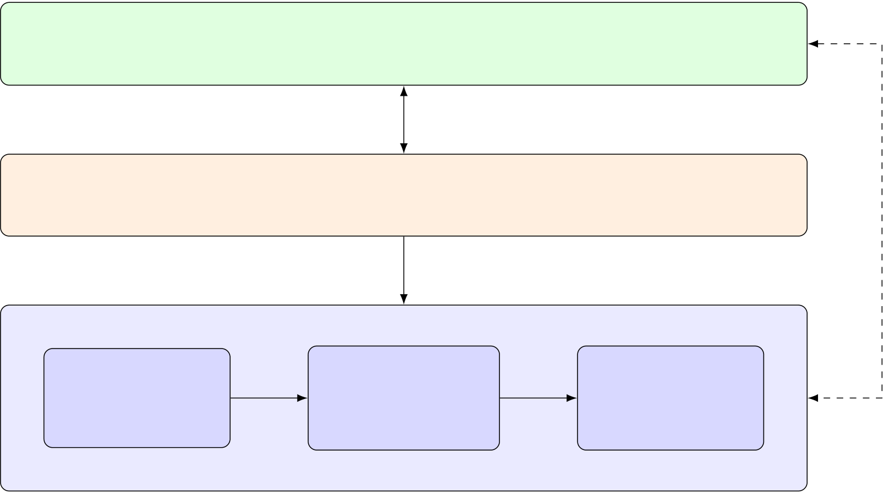
CHAPTER 3.SYSTEM ARCHITECTURE
ElectronRenderer(UI)  React/TypeScript/Tailwind—landingpageandworkspacetabs | HTTP / SSE
IPC (preload bridge)
Orchestration&IPC
Electronmainprocess+preloadbridge(window.api)
spawn / health-poll
Python AI Engine — FastAPI backend (:8080)
PartA | PartB | PartC
Requirement | Testgeneration | Automated
 | +bugdetection | repair
extraction
Qwen2.5-Coder-7B-Instruct (4-bit NF4) + LoRA adapters + three-layer RAG
Figure 3.1:High-Level System Architecture of TestMate
3.2 Desktop Application Architecture (Electron)
TestMate is packaged as an Electron application.Electron allows a cross-platform desktop graphical interface to be built with standard web technologies — here React, TypeScript, and Tailwind CSS — while still launching and supervising a native Python process that hosts the AI pipeline; the same code base can then be packaged into a desktop installer.The application follows Electron’s standard three-role process model, illustrated in Figure 3.2.
Themainprocesscreatestheapplicationwindowandisresponsibleforthebackend’s lifecycle:it spawns the Python server as a child process, waits for the server to report readi-nessonitsstatusendpoint,automaticallyrestartsthebackendifitcrashes,andterminates itwhentheapplicationquits.ForsecurityitdisablesNodeintegrationintherendererand enables context isolation.
The preload bridge runs in an isolated context between the main process and the renderer. UsingElectron’scontextBridge,itexposesonlyaminimal,explicitlydefinedinterface (window.api) to the renderer — principally the backend’s base URL together with a small number of inter-process hooks — rather than granting the renderer direct access to Node or the operating system.
The renderer hosts the entire React user interface.It issues REST calls to the backend and listens on SSE streams for incremental results, but performs no heavy computation locally;all model inference and analysis happen in the Python process.A few control events (such as opening the settings panel and signalling that the backend has restarted) are exchanged be-tween the main process and the renderer over Electron’s inter-process communication (IPC) channels.
16

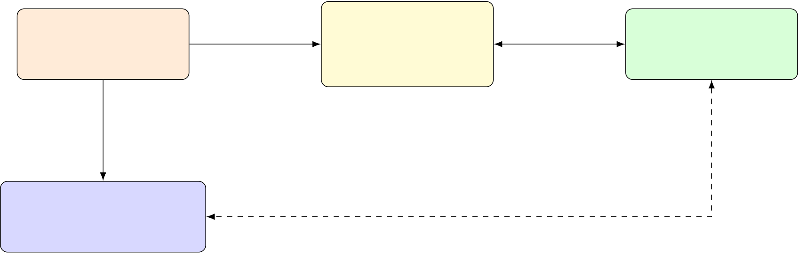
CHAPTER 3.SYSTEM ARCHITECTURE
ElectronMain | exposes | PreloadBridge | IPC | Renderer(UI)
 | window.api
 |  | contextBridge
main.ts |  |  |  | Reactapplication
 |  | window.api
spawn /
health-poll
PythonAIBackend
FastAPI(:8080) HTTP / SSE
Figure 3.2:Electron Process Model and IPC
3.3 The AI Engine
TheintelligenceofTestMateisprovidedbyasinglecodemodelhostedlocally.Thebase model, Qwen2.5-Coder-7B-Instruct, is loaded in 4-bit NF4 (NormalFloat) quantisation through the bitsandbytes library, with an 8-bit load as a fallback.The compute data type is selected accordingtoavailablememory—halfprecision(FP16)onGPUswithuptoabout10GB of VRAM, and BF16 above that threshold.Attention uses the scaled dot-product attention (SDPA) backend, and key/value caching is enabled to accelerate decoding.Quantisation re-duces the model’s footprint enough to run on a single consumer NVIDIA GPU with roughly 6–8 GB of VRAM. The model weights and adapters are distributed out of band rather than bundled with the source repository.
Rather than maintaining separate models for each task, Part B and Part C share one resi-dent Qwen base with two task-specific LoRA [5] adapters that are hot-swapped on demand: switching the active adapter (a near-instant operation) reconfigures the shared model for test generationorforrepairwithoutreloadingthebackbone.Theadaptersaresmall,low-rank updates trained with rank 16 and scaling factor 32.
AcentralconstraintontheengineisGPUmemorycoexistence.Themodelusedby therequirement-extractionstepandthemainQwenmodelmustneverberesidentonthe GPUatthesametime.Theenginethereforemanagesmodellifetimeexplicitly:amodel isloaded,itsstageisrun,anditsmemoryisreleasedbeforethenextmodelisloaded.To guaranteethatmemoryisfullyreclaimed,thelighterREADME-extractionsteprunsinan isolatedsubprocess,because4-bitquantisedmodelsdonotreliablyreleaseVRAMwhen unloaded in-process on Windows.A resident “keep-alive” model can be held warm to serve interactiverequestsandisunloadedautomaticallyafteraperiodofinactivity.ThisGPU lifecycle management is centralised in a single module so that the coexistence rule is enforced consistently across the pipeline.
17

CHAPTER 3.SYSTEM ARCHITECTURE
3.4 | Component Design
TestMate’s functionality is divided into three components whose outputs feed one another in sequence, coordinated by the orchestrator.
Part A — Requirement extraction.Part A converts project documentation into struc-tured requirements.From an SRS document it produces sentence-level labelled requirements, distinguishing requirement statements from background prose.From a README it uses the language model to extract project features and to generate structured test scenarios.Its out-puts are a list of labelled requirements and a list of scenarios.A requirement matcher then selects, for each target source file, the most relevant requirements using a hybrid of keyword overlapandsemanticsimilarity,sothatdownstreamgenerationisfocusedontherequire-ments that pertain to the file under test.
Part B — Test generation and bug detection.Part B is the AI core of the system.For each source file it assembles a rich context — drawn from static analysis of the code (such as the abstract syntax tree, control-flow paths, and the call graph), the matched requirements, andtheRAGpipeline—andpromptstheQwenmodelwithitsactiveadaptertogenerate apytesttest.Thegeneratedtestisexecuted;failuresarefedbackintothenextiteration, and each candidate is assessed by the Bug Exposure Score (BES) quality gate before being accepted.Thecomponentproducesgeneratedtestfiles,anSRS-coveragesummary,and arecordofdetectedbugs.Bugdetectionisperformedbyconfidence-scoredoraclesthat classify each failure as a confirmed, suspected, or discarded bug.
Part C — Automated program repair.Part C consumes the failing tests and confirmed bugs produced by Part B, handed over through a dedicated bridge between the two compo-nents.It applies spectrum-based fault localisation (using the Ochiai metric) to rank the most suspiciouslines,promptstheQwenmodelwithitsrepairadaptertoproposeafix,andap-plies that fix with an abstract-syntax-tree-safe patching step that replaces only the matching functions.The candidate patch is verified by re-running the tests, with up to three attempts, and all of this happens in an isolated workspace so that the original source is never modified inplace.PartCemitsthepatchedsource,anattemptlog,thesuspicious-lineranking,and optionally a dedicated repair branch in version control.Its success or failure is reported back to Part B to promote or demote the corresponding bug’s confidence verdict.
The hand-offs between the components are therefore explicit:Part A’s requirements feed Part B through the requirement matcher, and Part B’s failing tests and confirmed bugs feed PartCthroughtherepairbridge,withafeedbackpathfromPartCbacktoPartB’sbug verdicts.
18

CHAPTER 3.SYSTEM ARCHITECTURE
3.5 | The Three-Layer RAG Pipeline
Tocompensateforthefactthatalanguagemodel’sbuilt-inknowledgecannotaccountfor the specific codebase under test, TestMate grounds generation in retrieved context organised into three architectural layers, each targeting a different kind of knowledge.
•Layer1—Generaltestingknowledge.Anofflinevectorindexofexternaltest-ing documentation and usage examples supplies general, framework-level knowledge about how tests are written.
•Layer 2 — Code-under-test context.A knowledge graph of the repository captures thestructuralrelationshipsofthecodebeingtested—suchasthefunctionsatarget calls and the classes it depends on — and is queried by a combination of keyword and semantic retrieval so that the most relevant code context can be supplied.
•Layer 3 — Accumulated test examples.A persistent memory of previously accepted, high-quality tests and recurring failure patterns lets the system reuse its own past ex-perience for the current codebase.
Architecturally, the role of the pipeline is to combine these three sources into a single body of grounding context that is injected into the generation prompt before each call to the model, sothatgenerationisinformedsimultaneouslybygeneraltestingpractice,bythespecific structure of the code under test, and by the system’s accumulated experience.The concrete retrieval mechanisms, indexing structures, and storage used by each layer are implementation matters and are described in Chapter 4.
3.6 Data Flow
Theend-to-endflowofdatathroughTestMatefollowsthechainofcomponentsdescribed aboveandissummarisedinFigure3.3.ThesystemtakesaPythonproject—suppliedas alocalpathoraGitHubURLanddiscoveredintoalistoftestablefiles—togetherwith optional SRS and/or README documentation and a set of run settings.
The documentation first passes through Part A, which yields labelled requirements (from theSRS)andprojectfeaturesandtestscenarios(fromtheREADME).Therequirement matcher then selects the requirements relevant to each target file.Part B consumes each file together with its matched requirements and retrieved context, generates and runs tests under the BES quality gate, and produces the generated test suites, an SRS-coverage summary, and a set of detected bugs triaged by the bug-detection oracles.When repair is enabled, the fail-ing tests and confirmed bugs flow into Part C, which localises the fault with spectrum-based fault localisation, proposes and applies a patch, and re-runs the tests to verify the repair.Fi-nally, all of these results — requirements, scenarios, generated tests, coverage, bug reports,
19

CHAPTER 3.SYSTEM ARCHITECTURE
fault-localisationrankings,andpatches—arestreamedincrementallytotheuserinterface
over SSE and presented in the corresponding workspace tabs.
InputProject | source | PartA | requirements, | PartB | failing tests, | PartC | patched | Outputs
 |  |  |  |  | bug reports
 | files |  | scenarios |  |  |  | code
+optional |  | Requirement |  | Testgeneration |  | Repair |  | tests,bugs,
SRS/README |  |  |  | (BESgate) |  | (SBFLOchiai) |  | patches
 |  | extraction
Figure 3.3:End-to-End Data Flow Through TestMate
20

Chapter 4
System Implementation
This chapter presents the detailed implementation of TestMate’s three functional components. In keeping with the documentation guidelines, the algorithms are described using pseudocode andflowchartsratherthansourcelistings.Thechapterfollowsthedatapaththroughthe system:requirementextraction(PartA),testgeneration(PartB),thethree-layerretrieval pipelinethatgroundsgeneration,theBugExposureScorethatgatestestquality,andauto-mated program repair (Part C).
4.1 Implementation Overview
TestMate is implemented as a desktop application with a clear split between its presentation layeranditscomputationallayer.TheapplicationshellisbuiltwithElectronandNode.js andhostsarendererwritteninReactandTypeScript,whiletheAIengineandallanalysis logic are implemented in Python.At runtime the Electron main process launches the Python service and communicates with it over HTTP and a Server-Sent Events stream, as described in Chapter 3.
The three functional parts are integrated as Python components invoked in sequence by an orchestrator:PartAproducesrequirementsandscenarios,PartBconsumesthosetogether witheachsourcefiletogenerateandvalidatetests,andPartCoptionallyrepairsthecode implicatedbythebugsPartBdetects.Thepartsshareasingleresidentlanguagemodel withtask-specificadapters,sointegrationatruntimeisamatterofroutingdatabetween components and switching the active adapter rather than launching separate models.
4.2 Part A — Requirement Extraction
PartAturnsprojectdocumentationintostructured,testablerequirements.Itacceptstwo kindsofinput—aSoftwareRequirementsSpecification(SRS)documentandaproject README — and handles each through a different path.
21

CHAPTER 4.SYSTEM IMPLEMENTATION
4.2.1 | SRS-based Extraction
For a structured SRS document, Part A uses a lightweight, non-neural path.The document is split into candidate sentences, and each sentence is aligned by fuzzy string similarity against acorpusoflabelledrequirements(thePURErequirementsdataset).Onthebasisofthis alignmenteachsentenceisassignedalabel(1,0,or −1)togetherwithamatchtypeanda similarity score, distinguishing requirement statements from non-requirements.Because this path relies on string matching and similarity rather than a language model, it needs no GPU and completes quickly, which makes it suitable for interactive use.
4.2.2 README-based Extraction
For a README, Part A uses a two-stage language-model path.The README text is first cleanedandnormalised.Afirstmodelcallthenextractstheproject’sfeaturebulletsfrom the cleaned text, and a second call generates structured test scenarios from those features.To respect the GPU memory-coexistence constraint described in Chapter 3, this extraction runs in an isolated subprocess so that its model is fully unloaded before the heavier test-generation model is brought in.
4.2.3 Pseudocode and Flowchart
Algorithm4.1summarisesthetwopaths,andFigure4.1showsthecorrespondingcontrol flow.
Algorithm 4.1 Part A — Requirement Extraction
Require:SRS document D (optional); README text R (optional)
Ensure:labelled requirements Q; test scenarios S
1:Q ←∅; S←∅
2:ifD is provided then
3: split D into candidate sentences
4: for all sentence s in D do
5: align s against the labelled PURE corpus by fuzzy similarity 6: assign s a label and score; add it to Q
7: end for
8:end if
9:ifR is provided then
10: clean and normalise R
11: Stage 1:prompt the model to extract feature bullets from R
12: Stage 2:prompt the model to generate scenarios from those features 13: add the generated scenarios to S
14:end if
15:return Q, S
22

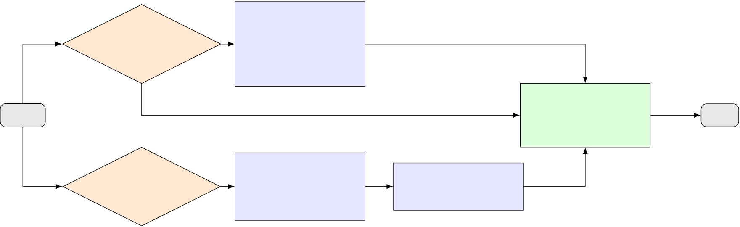
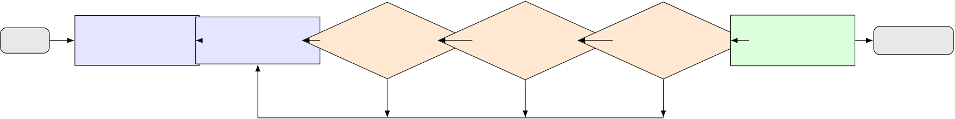
CHAPTER 4.SYSTEM IMPLEMENTATION
Fuzzy-align
SRS | yes | sentencesvs.
provided?
 |  | PURE;assign
label+score
Start | no | Collectrequire- | End
 |  | mentsQand
scenariosS
README | yes | CleanREADME; | Generatetest
 |  | extractfeature
provided? |  |  | scenarios(LLM)
 |  | bullets(LLM)
Figure 4.1:Part A Requirement-Extraction Pipeline
4.3 Part B — Test Generation
PartBisthecoreofTestMate.Foreachsourcefileitbuildsarichcontext,promptsthe languagemodeltogenerateapytesttest,runsthattest,andfeedsanyfailurebackintothe next attempt, gating every candidate on quality before it is accepted.
4.3.1 The Generate–Run–Fix Loop
Generationisiterativeandself-correcting.Foratargetfiletheloopgeneratesacandidate test, subjects it to a quick quality check (rejecting syntactically invalid tests, tautologies, and tests without real assertions) and then to the Bug Exposure Score gate; an accepted candidate is executed with pytest, and if it fails, the error is routed to a fix strategy and folded back into the prompt for the next attempt.The loop is bounded by a retry limit (up to fifteen iterations, with an optional wall-clock deadline).When a candidate passes, it is stored in the system’s test memory and de-duplicated against previously accepted tests; if the loop cannot produce anacceptabletest,thesystemfallsbacktodeterministictestsderivedfromdocstringsand boundary values.Algorithm 4.2 states the loop, and Figure 4.2 shows it with the BES gate as a decision node.
Start | Build | Generate | Quick | yes | BES | yes | pytest | yes StoreinRAG | Accepted
 | promptP | candidatetest | checkOK? |  | ≥70? |  | passes? | memory
 |  |  |  |  | no |  | no
 |  |  | no
retry:add quality / BES hints, or fold the pytest error into P
Figure 4.2:Part B Generate–Run–Fix Loop with the BES Quality Gate
4.3.2 Prompt Construction
Thequalityofthegeneratedtestsdependsonthecontextsuppliedtothemodel.Foreach target, Part B assembles a token-budgeted context that draws together the function’s source,
23

CHAPTER 4.SYSTEM IMPLEMENTATION
Algorithm 4.2 Part B — Self-Correcting Test Generation
Require:target file f; assembled context C; retry limit N
Ensure:an accepted test, or a deterministic fallback test
1:P←plan-then-execute prompt built from fand C
2:for i ←1 to Ndo
3: t ←GENERATETEST(P)
4:
ift fails the quick quality check then 5: append a targeted hint to P; continue
6: end if
7: b ←COMPUTEBES(t) ▷five-dimension score; gating in Section 4.5 8: ifb < 70 then
9: append BES-derived hints to P; continue
10: end if
11: r←RUNPYTEST(t)
▷on host or in Docker 12: ifr passed then
13: store t in RAG memory; de-duplicate; return t
14: else
15:
route the failure to a fix strategy and fold it into P 16: end if
17:end for
18:return deterministic docstring/boundary fallback test
docstring, and comments; static-analysis information including control-flow execution paths,
raised exceptions, and a two-hop slice of the call graph (callers, callees, and siblings); base
classes and data-flow facts; detected framework setup; the requirements matched to the file;
retrievedRAGexamplesofgoodandbadtests;andautomaticallyprimedstyleexamples
taken from existing passing tests in the repository.Requirements are matched to each file by
a hybrid scheme that first scores requirements by keyword overlap with the file’s identifiers
and then, if needed, re-ranks the survivors by semantic similarity.This material is arranged
intoa two-phase“plan-then-execute” promptthat firstasks themodel toplan thetests and
then to produce them.The model’s output is a pytest file delimited by markup tags,which
is post-processed (code extraction,assertion fixing,de-duplication,and tautology filtering)
before being executed.
4.4 The Three-Layer RAG Pipeline
Chapter 2 introduced the theory of retrieval-augmented generation and Chapter 3 its role in
the architecture; this section describes how the three layers are implemented and queried.
4.4.1 Layer 1 — General Testing Knowledge
The first layer supplies general,framework-level testing knowledge from an offline corpus
of external documentation and usage examples.Documents are encoded into dense embed-
24

CHAPTER 4.SYSTEM IMPLEMENTATION
ding vectors with a sentence-transformer model [11] (the all-MiniLM-L6-v2 encoder) and stored in a FAISS index [12].At query time the target code is embedded in the same space and the nearest documents are retrieved by vector similarity, providing approximate nearest-neighbour search that remains fast as the corpus grows.
4.4.2 Layer 2 — Code-under-Test Context
Thesecondlayerretrievesthestructuralcontextofthecodebeingtested.Therepository is represented as a code knowledge graph whose nodes and edges capture call relationships and dependencies between functions and classes.Retrieval over this graph is hybrid:lexical matchingwithBM25[13]locatesdefinitionsbyexactsymbolname,whilesemanticsimi-larity generalises beyond exact matches, and a two-hop traversal collects the callees, callers, and sibling functions most relevant to the target.This yields the specific cross-file context— such as the functions a target calls and the classes it depends on — that the model needs to write meaningful tests.
4.4.3 Layer 3 — Accumulated Test Examples
The third layer is a persistent memory of the system’s own experience:previously accepted, high-quality tests together with recurring failure patterns,kept in a local SQLite store with associated trust scores.Entries are retrieved by embedding similarity to the current target, so that tests which worked well for similar code can guide new generation.As described in the generate–run–fix loop, every test that passes is written back into this memory, which lets the layer improve as the system is used.
4.4.4 Context Fusion
The three layers are complementary, and their results are fused into a single body of ground-ingcontextbeforeeachgenerationcall.Layer1contributesgeneraltestingknowledge, Layer2thestructureofthecodeundertest,andLayer3thesystem’saccumulatedexpe-rience;togetherwiththematchedrequirementsandprimedstyleexamples,thiscombined contextisinjectedintotheplan-then-executepromptwithinafixedtokenbudget.Inthis way a single prompt is grounded simultaneously in general practice, in the specific code, and in past results, which provides richer grounding than any one source alone.
4.5 The Bug Exposure Score (BES)
The Bug Exposure Score is one of TestMate’s distinctive contributions:a quantitative gate that estimates how well a generated test would actually expose faults, applied to every can-didate before it is accepted.
25

CHAPTER 4.SYSTEM IMPLEMENTATION
4.5.1 | Motivation
Structuralcoveragealoneisapoorproxyfortestquality.Atestcanexecutemanylines ofafunction—achievinghighcoverage—whileassertingnothingmeaningfulaboutthe results,sothatitpassesregardlessofwhetherthe code is correct and therefore exposes no bugs.TestMate’s own experience illustrates this:a weak test that a coarse coverage-oriented scorer rated highly was found to detect none of a set of injected bugs, whereas the BES gate correctly rejected it.BES is designed to measure fault-exposing power directly rather than mere execution, so that only tests with genuine discriminating ability are accepted.
4.5.2 The Five Dimensions
BES combines five weighted dimensions, each assessing a different aspect of a test’s fault-exposing power:
•Specification Coverage (30%) — whether documented examples from the function’s docstring appear as concrete assertions in the test.
•InputVariety(25%)—thediversityoftheinputsexercised,acrosscharacteristics such as letter case, sign, type, and emptiness.
•Boundary Coverage (20%) — the presence of boundary values, verified against the test’s syntax tree, such as the empty string, 0, −1, the empty list, the empty dictionary, and None.
•AssertionQuality(15%)—thestrengthoftheassertions,favouringexactequality checks,pytest.raisesforexpectedexceptions,andatleasttwodistinctexpected values.
•Mutation Potential (10%) — a heuristic estimate of the test’s ability to kill common mutations, such as altered operators, constants, return values, and booleans.
4.5.3 Scoring Formula and Gating
Each dimension yields a normalised sub-score si∈[0, 1].These are combined by a weighted sum, scaled to a 0–100 range:
BES = 100 × | (  0.30 sspec + 0.25 svar + 0.20 sbound + 0.15 sassert + 0.10 smut | )  . | (4.1)
Theresultingscoredrivestheacceptancegate.Atestscoringatleast70isaccepted immediately.A test scoring between 50 and 69 triggers a single retry, with hints derived from its weakest dimensions appended to the prompt.A test scoring below 50 is retried up to three
26

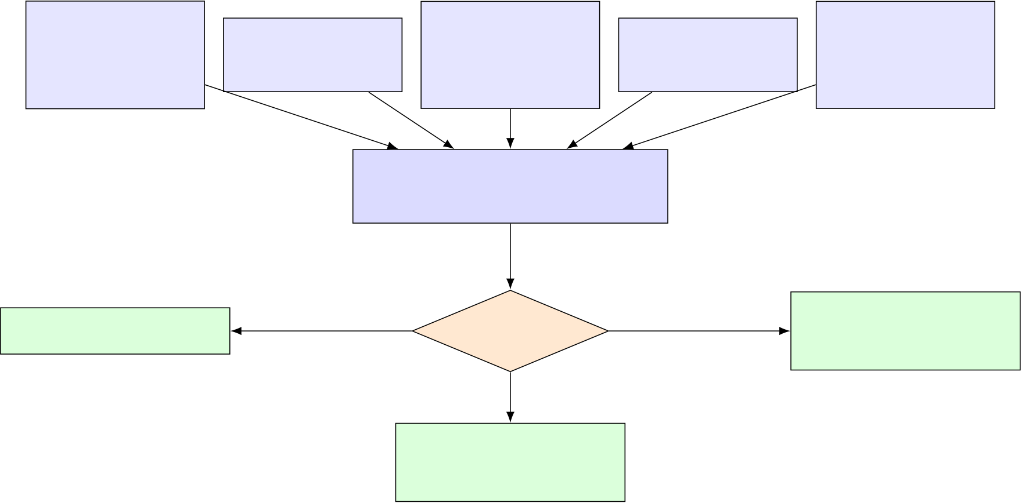
CHAPTER 4.SYSTEM IMPLEMENTATION
times with such hints, after which the system falls back to deterministic tests generated from docstrings and boundary values.Figure 4.3 shows the computation and the gating decision.
Specification | Input | Boundary | Assertion | Mutation
Coverage |  | Coverage |  | Potential
 | Variety(25%) |  | Quality(15%)
(30%) |  | (20%) |  | (10%)
Weightedsum
×100=BES
Accept(≥70) | BEStier? | Retry≤3×,then
 |  | fallback(<50)
Retryonce
(50–69)
Figure 4.3:Bug Exposure Score Computation and Gating Decision
4.6 Part C — Automated Program Repair
Whenrepairisenabled,PartCattemptstocorrectthecodeimplicatedbythefailingtests that Part B produced.It localises the likely fault, prompts the model for a fix, applies that fix safely, and validates it by re-running the tests.
4.6.1 Spectrum-based Fault Localization
Part C first identifies where the fault is most likely to lie using spectrum-based fault local-isation.Itrunsthetestswhilecollecting,foreachlineoftheprogram,howmanypassing and failing tests execute it — the execution spectrum.Lines are then ranked by their suspi-ciousness using the Ochiai metric [27].For a line ℓ, let efbe the number of failing tests that execute ℓ,epthe number of passing tests that execute ℓ,and nfthe number of failing tests that do not execute ℓ(so that ef + nfis the total number of failing tests).The suspiciousness is
Ochiai(ℓ) = | ef√  (ef+ nf) (ef+ ep) | . | (4.2)
The most suspicious lines (the top ranked) are selected to focus the repair.If no usable spectrumcanbecollected—forexamplewhenthefilecontainsasyntaxerror—PartC instead targets a full-file fix.
27

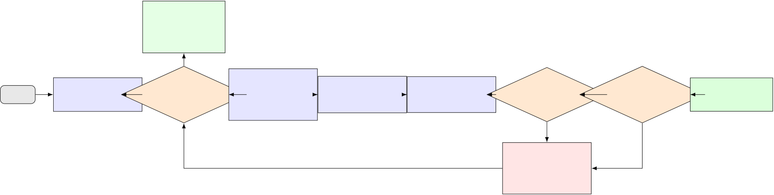
CHAPTER 4.SYSTEM IMPLEMENTATION
4.6.2 | Patch Generation
The ranked locations are used to construct a targeted repair prompt that combines the failing test’s trace,thesuspiciouslines,the surroundingcode snippet,and thefull source file.On a repeated attempt the prompt additionally carries a warning that the previous fix failed and that a different approach should be tried, and the sampling temperature is raised to encourage a more varied candidate.The model, using its repair adapter, produces a candidate fix.
4.6.3 AST-safe Application and Validation
The candidate fix is not applied as raw text.Instead, the model’s output is parsed and only the functions whose definitions match those in the original file are replaced, leaving the rest of the file untouched; a full-file replacement is used only when the original file had a syntax error, and a candidate that contains no matching functions is rejected outright.The patched fileisthenvalidatedbyre-runningthetestsuite.Allofthishappensonasnapshotinan isolated workspace, so a failed attempt can be rolled back to the original; a successful patch can optionally be committed to a dedicated repair branch in version control.Algorithm 4.3 states the loop and Figure 4.4 shows its control flow.
Source
already
healthy
yes
Start | Snapshot | Tests | no | Collect | Ranklinesby | Buildprompt; | Functions | yes | Tests | yes | Patched
 |  |  |  | coverage
 |  | pass? |  |  | Ochiai(top-k) | generatefix |  |  | pass?
 | source |  |  |  |  |  | match? |  |  |  | source
 |  |  |  | spectrum
no
Restore | no
snapshot;
nextattempt
Figure 4.4:Part C SBFL-Guided Repair Loop
4.7 LoRA Fine-Tuning
To make the 7-billion-parameter base model competitive for test generation without the cost of full fine-tuning, TestMate specialises it with LoRA supervised fine-tuning: the base weights are frozen and only a small low-rank adapter is trained on input–output examples.This sec-tion describes the training data and its decontamination, the configuration used, and the train-ing procedure.
4.7.1 Dataset and Decontamination
The reported (headline) model is fine-tuned with supervised learning on training data derived fromtheMBPP(MostlyBasicPythonProblems)dataset.BecauseMBPP-styleproblems
28

CHAPTER 4.SYSTEM IMPLEMENTATION
Algorithm 4.3 Part C — SBFL-Guided Repair Loop
Require:buggy source f; failing test suite T; maximum attempts M
Ensure:a patched source that passes T, or the restored original
1:snapshot f0←f ▷for rollback 2:for a ←1 to Mdo
3: ifRUNTESTS(f, T) all pass then
4: return f
5: end if
6: collect the per-test coverage spectrum
7: ifa spectrum exists then
8: rank lines by Ochiai suspiciousness; take the top-k
9: else
10: target a full-file fix ▷e.g. a syntax error 11:
end if 12: build the repair prompt (trace + suspicious lines + snippet + full code)
13: ifa > 1 then
14: add a “previous fix failed” warning and raise the temperature
15:
end if 16: p ←GENERATEFIX(prompt)
17: f′←ASTSAFEPATCH(f, p) ▷replace only matching functions 18: iff′has no matching functions then
19: restore f←f0; continue
20: end if
21: ifRUNTESTS(f′, T) all pass then
22: return f′
23: else
24: restore f←f0
25: end if
26:end for
27:return f0 | ▷attempts exhausted; original restored
29

CHAPTER 4.SYSTEM IMPLEMENTATION
can overlap with the public benchmarks used for evaluation, the training data is decontam-inated against HumanEval,so that the HumanEval, TestEval, and TestGenEval evaluations are contamination-free; the decontamination is performed by a dedicated script that records the retained problem identifiers.Reporting on a contamination-free model is important be-cause it ensures the measured gains reflect genuine generalisation rather than memorisation of the test sets.
A larger training mixture was also explored as an alternative configuration:it combined approximately 600 SWE-bench samples (with test code extracted from patches), about 200 samples from Magicoder-Evol-Instruct-110K, and about 200 MBPP samples, formatted with thesourceandgraphcontextasinputandthegeneratedtestsasthetarget,atamaximum sequencelengthof2048tokens.Thismixtureisdescribedhereonlyasanexploredcon-figuration;the headline results in this chapter are those of the MBPP-only, decontaminated model.
4.7.2 Hyperparameters and Setup
Table4.1liststheLoRAfine-tuningconfigurationofthereportedtest-generationmodel. Only values stated in the project record are included.
Table 4.1:LoRA supervised fine-tuning configuration (reported test-generation model)
Setting | Value
Adaptation method Rank (r)  Scaling factor (α) LoRA dropout | LoRA supervised fine-tuning 16  32  0.05

Target modules
Base-model quantisation

q_proj, k_proj, v_proj, o_proj 4-bit NF4 (bitsandbytes)

 | Epochs | 1
 | Per-device batch size | 1
 | Gradient accumulation | 8
 | Learning rate | 2 × 10−4
 | Warmup ratio | 0.1
 | Precision | FP16
 | Optimiser | paged_adamw_8bit
 | Gradient checkpointing | enabled
 | Max sequence length | 2048
 | Training hardware | Kaggle T4 GPU
4.7.3 | Training Procedure
The procedure is summarised in Algorithm 4.4.The base model is loaded in 4-bit NF4 form andpreparedforlow-bittraining,afterwhichaLoRAadapterisattachedtotheattention
30

CHAPTER 4.SYSTEM IMPLEMENTATION
projectionmodules.Eachtrainingexampleisformattedasaprompt—thesourceunder test together with its graph context — paired with the corresponding tests as the target.Ex-amplesaretokenisedtoamaximumlengthof2048withpaddingtothatlength,andthe labels are set equal to the input token identifiers so that the model is trained with the standard causal-language-modelling objective (using a language-modelling data collator with masked-language modelling disabled).Training runs for a single epoch with the hyperparameters of Table 4.1.On completion, only the small adapter is saved (together with a metadata file); at inference time this adapter is loaded on top of the resident 4-bit base model and activated for generation, which is what makes the per-task hot-swapping described in Chapter 3 possible.
Algorithm 4.4 LoRA Supervised Fine-Tuning of the Test-Generation Adapter Require:base model M(4-bit NF4); training set D; epochs E
Ensure:trained LoRA adapter
1:prepare Mfor low-bit training; freeze base weights
2:attach a LoRA adapter (r=16, α=32, dropout 0.05) to {q,k,v,o}_proj 3:for all example (source, context, tests) in D do
4: form prompt p ←source + graph context;
target ←tests 5: tokenise (p, target) to length 2048 (pad to max); set labels = input ids 6:end for
7:for e ←1 to Edo
8: train the adapter with the causal-LM loss (batch 1, grad-accum 8, lr 2×10−4) 9:end for
10:save the adapter weights and metadata
11:at inference:load Min 4-bit; attach the saved adapter; activate it
4.8 | Results and Discussion
Thissectionreportshowthefine-tuned,RAG-augmentedsystemperformsagainsttheun-tuned base model on public benchmarks, and discusses what the results mean.
4.8.1 Experimental Setup
Test generation is evaluated along three axes — coverage, correctness, and bug detection —on three benchmarks with distinct roles.TestEval (210 LeetCode programs) is the external headline benchmark; HumanEval (164 problems) is used as an internal system-versus-base sanitycheckonthetest-generationtask;andTestGenEval-Lite(SWE-bench-derivedreal code, matched N= 30) supplies a directional RAG-lift signal.Automated repair is evaluated onHumanEvalFix(164items).Thetest-generationmetricsareline/branchcoverage,pass rate (pass@1), mutation score, and the Bug Exposure Score (BES); the repair metrics are the repair success rate together with the average time and average number of attempts per bug. The baseline throughout is the un-tuned Qwen2.5-Coder-7B model (the same model without
31

CHAPTER 4.SYSTEM IMPLEMENTATION
the LoRA adapter);accordingly,the LoRAand RAG contrasts reported below are system-level ablations rather than isolated single-component ablations.All numbers are single runs at a generation temperature of 0.3, without multi-seed repetition.As noted above, the fine-tuned modelisdecontaminatedagainsttheevaluationdata,sothecomparisoniscontamination-free.
4.8.2 Test-Generation Results (TestEval)
The headline test-generation evaluation uses TestEval, the recognised external test-generation benchmark of 210 LeetCode programs, run in suite/coverage mode.This is the result against whichTestMate’stest-generationcapabilityshouldbejudged,becauseTestEvalisanes-tablished,independently-definedbenchmarkratherthananinternalcomparison.Table4.2 compares the un-tuned base model (no LoRA) with the full TestMate system on all four axes the harness records.
Table4.2: Headlinetest-generationresultsonTestEval(210LeetCodeprograms, suite/coverage mode):base model vs. TestMate
Metric | Base (no LoRA) | TestMate
Line coverage | 78.9% | 93.8%
Pass rate | 79.8% | 97.6%
Mutation score (per file) | 89.8% | 81.5%
Programs with passing tests | 168/210 | 205/210
On TestEval, TestMate reaches 93.8% line coverage and a 97.6% pass rate, producing tests that pass on 205 of the 210 programs, against 78.9% line coverage, 79.8% pass rate, and 168of210programsfortheun-tunedbase.Forexternalcontext,theprojectrecordnotes amuchlargerproprietarymodel(GPT-4o)attaining98.7%linecoverageonTestEval,so TestMate’ssuite-modecoverageisstrongforanopen7-billion-parametermodelbutdoes not surpass the largest closed systems.
Anhonestbug-detectiontrade-off. Themutationscore(theproportionofinjectedmu-tants the generated tests kill) does not move in the same direction as the other metrics, and itwouldbemisleadingtopresentTestEvalasacleanacross-the-boardwin.Measuredper file,thebasemodelhasahighermutationkillrate(89.8%)thanTestMate(81.5%).How-ever, the base model only produces a passing test suite on 168 of the 210 programs, whereas TestMate does so on 205 — roughly 22% more programs.The correct reading is therefore atrade-off:TestMategeneratesbug-catchingtestsonsubstantiallymoreprogramsbutis slightly less precise, per file, at killing mutants on the programs both systems cover.Neither system dominates the other on this axis, and the breadth-versus-precision tension is itself an informative result.
32

CHAPTER 4.SYSTEM IMPLEMENTATION
4.8.3 | Three-Axis Evaluation:Why Coverage Alone Is Misleading
Acentralfindingofthisevaluation—andoneofitscontributions—isthatasinglecov-erage number cannot characterise a test generator, because the number is determined by the objective the generator is asked to optimise.TestMate is evaluated along three distinct axes: coverage (how much of the program the tests execute), correctness (whether the generated tests pass against the reference implementation,i.e. pass@1 / pass rate),and bug detection (whether the tests kill injected mutants).These three are not interchangeable, and optimising for one does not imply the others.
Theclearestdemonstrationcomes fromrunningthe same systemon thesameTestEval benchmarkundertwodifferentobjectives.Insuite/coveragemode—wheretheobjective is to cover the program — TestMate scores 93.8% line coverage and a 97.6% pass rate.In quality mode — where the objective is a single,strictly-gated,high-assurance test per pro-gram — the same system on the same programs scores only 42.5% line coverage and 16.7% pass@1.Table 4.3 makes the contrast explicit.
Table 4.3:The same TestMate system on the same TestEval benchmark under two objectives: a single coverage number is objective-dependent
Metric | Suite mode | Quality mode
Line coverage | 93.8% | 42.5%
Pass rate / pass@1 | 97.6% | 16.7%
BES | — | 56.47
The same system swings from 93.8% to 42.5% line coverage purely by changing what it is asked to do.This is direct proof that a single coverage figure is meaningless without its objective, and it is why TestMate reports coverage, correctness, and bug detection together rather than collapsing them into one headline percentage.
4.8.4 Internal Corroboration on HumanEval
HumanEval is used here as an internal sanity check, not as a leaderboard result.The compar-ison is the full TestMate system against the same base model on the same 164 HumanEval problems, which isolates the effect of TestMate’s adaptation on a second, independent set of programs and corroborates the TestEval trend.On HumanEval the system roughly doubles everyrecordedmetricoverthebase:test-generationpass@1risesfrom33.5%to60.4%, coverage from 34.1% to 67.6%, on N= 164 problems.
Twocaveatsmustbestatedplainly.First,thesearetest-generationnumbers:thetask is generating a test for each problem, not solving the problem.They must not be compared with the well-known HumanEval code-generation pass@1 leaderboard, which measures an entirely different task and on which much higher numbers are routine.Second, this is an inter-
33

CHAPTER 4.SYSTEM IMPLEMENTATION
Table 4.4:Internal corroboration on HumanEval (TestMate vs. the same base model,N= 164).Thesearetest-generationfiguresandarenotcomparabletocode-generationleader-boards.
Metric | Base (same model) | TestMate
pass@1 (test generation) | 33.5% | 60.4%
Coverage | 34.1% | 67.6%
Branch coverage | — | 39.56%
BES | — | 58.34
nal system-versus-base comparison, not an externally-defined benchmark score; the external headline for test generation is TestEval (Table 4.2).
4.8.5 Automated-Repair Results
Table 4.5 reports Part C’s performance on the 164 HumanEvalFix bugs, for the un-tuned base model and for two fine-tuned configurations.
Table 4.5:Automated program repair on 164 HumanEvalFix bugs
Configuration | Total | Fixed | Repair rate | Avg. time (s) | Avg. attempts
Base Qwen (baseline) | 164 | 111 | 67.68% | 23.31 | 1.0
LoRA, single attempt | 164 | 138 | 84.15% | 31.05 | 1.0
LoRA + iterative (TestMate) | 164 | 150 | 91.46% | 44.03 | 1.25
The repair results show a clear, monotone improvement.The un-tuned base model fixes 111of164bugs(67.68%)inasingleattempt.AddingtherepairLoRAadapterraisesthis to138fixes(84.15%)whilestillusingasingleattemptonaverage.Allowingtheiterative generate–localise–patchlooptorun(TestMate’sfullconfiguration)raisesitfurtherto150 fixes (91.46%),at the cost of more time per bug (44.03 s vs. 23.31 s) and a slightly higher averageof1.25attempts.Theheadlineimprovementisthereforeariseintruerepairrate from 67.68% to 91.46% over the un-tuned baseline.
4.8.6 System-Level Ablations
Theprojectrecordprovidestwocontrolledcomparisonsthatboundthecontributionofthe maintechniques,showninTable4.6:removingtheLoRAadapter(theun-tunedbaseline) onHumanEval,andremovingtheRAGcontextonrealcode(TestGenEval-Lite,matched N= 30).These are deliberately labelled system-level ablations rather than isolated single-component ablations.The “no-LoRA” and “no-RAG” baselines do not merely switch off one component while holding everything else fixed;they run a lighter generation path,so each comparison reflects the contribution of a whole subsystem (the adapted model; the retrieval
34

CHAPTER 4.SYSTEM IMPLEMENTATION
pipeline) rather than a cleanly-isolated single variable.An isolated seven-condition compo-nent ablation (separating the graph and vector retrieval layers, the self-correcting loop, and the planning step) was not produced, and no such numbers are claimed here.
Table 4.6:System-level ablations:effect of LoRA fine-tuning and of RAG
Configuration | Benchmark | Metric | pass@1
Without LoRA (un-tuned) | HumanEval (internal) | pass@1 | 33.5%
With LoRA (TestMate) | HumanEval (internal) | pass@1 | 60.4%
Without RAG | TestGenEval-Lite (N= 30) | pass@1 | 6.7%
With RAG (TestMate) | TestGenEval-Lite (N= 30) | pass@1 | 13.3%
The LoRA ablation is the internal HumanEval comparison already discussed (Section 4.8.4): adapting the model lifts test-generation pass@1 from 33.5% to 60.4%.
RAGliftonrealcode. TheRAGablationisrunonrealcoderatherthanself-contained benchmarkprograms,usingtheTestGenEval-Liteslice(matchedN=30).HereRAG roughly doubles correctness:pass@1 rises from 6.7% with retrieval off to 13.3% with Test-Mate’s full retrieval on.The effect is sharper still on the individual retrieval hits:with RAG off neither layer contributes (graph-RAG 0%,vector-RAG 0%),whereas with RAG on the graphlayerhitson27%ofcasesandthevectorlayeron57%.Valid-linecoveragemoves onlymarginally,from29.3%to31.9%.Thepointisthatonrealcodecoverageisnotthe headline:hard, real-world imports leave many files at 0% coverage regardless of retrieval, soRAG’smeasurablevaluehereisincorrectness,notcoverage.BecauseN=30,these RAG figures are reported as directional rather than statistically conclusive.
TheeffectoftheBESqualitygateisillustratedbyareportedcontrastonasmallbug-seededexample:aweaktestthatacoarsecoverage-orientedscorerrated80/100isscored 36.5/100 by BES and rejected, whereas a strong test scored 100 by the coarse scorer is scored 82.5byBESandaccepted;underthegatedpipelinethenumberofbugsdetectedonthat example rose from 0 of 5 to 3 of 5 and the number of generated test functions from 1 to 13.
4.8.7 Per-Benchmark Summary
The evaluation spans four public benchmarks — three for test generation and one for repair. Table4.7consolidatesthemintoasingleview,givingeachbenchmark’ssize,thetaskit measures,andtheheadlineTestMateresult,withthedetailedmetricsbehindthesefigures appearing in Tables 4.2, 4.5, and 4.6.
Thesummarymakesthebreadthoftheevaluationexplicitandkeepstherolesofthe benchmarks distinct.The external test-generation headline is TestEval (93.8% line coverage and a 97.6% pass rate in suite mode); HumanEval is an internal system-versus-base corrobo-ration on the test-generation task (pass@1 60.4%) and must not be read as a code-generation
35

CHAPTER 4.SYSTEM IMPLEMENTATION
Table 4.7:Per-benchmark summary of the evaluation
Benchmark | Size | Task | Headline TestMate result
TestEval | 210 programs | Test generation (headline) | 93.8% line cov., 97.6% pass rate
HumanEval | 164 problems | Test generation (internal) | pass@1 60.4%
TestGenEval-Lite | 30 (matched) | Test generation (RAG, directional) | pass@1 13.3%
HumanEvalFix | 164 bugs | Automated repair | Repair rate 91.46%
leaderboard number; TestGenEval-Lite supplies a directional RAG-lift signal on real code at a matched N=30; and automated repair is assessed by the fraction of bugs fixed (91.46% of 164 HumanEvalFix bugs).The size column also makes clear that these are function- and program-level benchmarks rather than large multi-file projects.
4.8.8 Worked Example:Repairing a Real Defect
Tomakethepipelineconcrete,thissubsectiontracesasinglecaseendtoend,usingthe walkthroughdocumentedinChapter5.Thesubjectiscore_utils.py,arealsourcefile containing a discount-calculation bug, together with the test suite that exercises it.
1.Run tests.Part C first runs the existing suite against the file; the tests fail, confirming a defect to repair.
2.Localize (SBFL). The per-test coverage spectrum is collected and the lines are ranked bytheirOchiaisuspiciousness.Forthisfilethelocaliseridentifiesfivesuspicious locations as the most likely fault sites.
3.Generate and patch.The ranked locations, the failure trace, and the surrounding code are assembled into a repair prompt; the model proposes a fix, which is applied through AST-safe function replacement — a single patch in this case.
4.Re-test and verify.The patched file is re-run against the suite,and all tests pass,so the repair is accepted.As reported in Chapter 5 (Figure 5.6), the bug is fixed in a single attemptin 69.6seconds,andthediff view(Figure 5.7) shows the correcteddiscount rate — a genuine logic fix validated by the suite passing afterwards.
Thesamewalkthroughalsoillustratesthetest-generationside:forthebenchmarkfile HumanEvalFix_053.py,thegenerate–run–fixloopproducedapytesttestreaching100% coverageanda100%mutationscore(Figure5.4).Togetherthesetwocasesshowthefull pipeline — generation, gating, localisation, and repair — operating on concrete inputs in the manner the aggregate metrics summarise.
36

CHAPTER 4.SYSTEM IMPLEMENTATION
4.8.9 | Threats to Validity
The evaluation should be read with the following honest caveats in mind, which bound the claims that can be drawn from it.
•Single-run, single-temperature.All reported numbers are single runs at a generation temperatureof0.3.Thereisnomulti-seedrepetitionandthereforenosignificance testing; small differences between configurations should not be over-interpreted.
•TestEval is a faithful re-implementation.The TestEval numbers come from a faithful re-implementation that approximates the official TestEval harness, not from the official harness itself; absolute values may differ slightly from a leaderboard run.
•TestGenEval-Liteisdirectional.TheRAG-liftresultonrealcodeisatamatched N= 30 and is reported as directional rather than statistically conclusive.
•Ablations are system-level.The LoRA and RAG contrasts are system-level ablations (fullTestMatevs.base,vs.no-RAG),becausethebaselinesusealightergeneration path;they are not isolated single-component ablations,and no seven-condition com-ponent ablation was produced.
•HumanEvalisinternal.TheHumanEvalcomparisonisaninternalsystem-versus-base sanity check on the test-generation task, not an external benchmark score, and is not comparable to code-generation leaderboards.
•Contaminationiscontrolled.The reportedmodel isfine-tunedon MBPPonly,de-contaminated against the evaluation sets, so the gains reflect generalisation rather than memorisation;thelargerSWE-bench+Magicoder+MBPPmixturewasexploredbut is not the configuration evaluated above.
•Scope.AllfourbenchmarksarePython,exercisedthroughpytest,atfunction-and program-level rather than large multi-file repositories, so behaviour on other languages and at repository scale is not directly measured; and the strongest coverage result still trails the much larger proprietary GPT-4o (98.7% TestEval line coverage), indicating remaining headroom.
4.8.10 Discussion
The results support the central claim of the project:a small, locally-run open-weights model can be made substantially more effective through careful engineering rather than sheer scale. OntheexternalTestEvalbenchmarkTestMatereaches93.8%linecoverageanda97.6% passrate(against78.9%/79.8%forthebase model);theinternal HumanEval comparison corroboratesthisbyroughlydoublingtest-generationpass@1andcoverageoverthesame
37

CHAPTER 4.SYSTEM IMPLEMENTATION
base;the three-layer RAG context roughly doubles correctness on real code (TestGenEval-Lite, directional); and the combination of fine-tuning with the iterative repair loop raises the HumanEvalFix repair rate from 67.68% to 91.46%.A further finding, foregrounded above, is methodological:because the same system swings from 93.8% to 42.5% line coverage on the same benchmark purely by changing its objective, coverage alone is an unreliable summary of a test generator, and the three axes (coverage, correctness, bug detection) must be reported together.Because the fine-tuned model is decontaminated against the evaluation sets, these gainscanbereadasgenuinegeneralisationratherthantest-setmemorisation,whichisthe most important methodological safeguard behind the numbers.
At the same time the results should not be overstated.TestMate’s strongest test-generation coverage (93.8% line coverage on TestEval in suite mode) remains below the 98.7% reported for a much larger proprietary model; its strict quality mode trades pass rate for assurance; and the bug-detection axis is a genuine trade-off rather than a clean win — the base model has a higher per-file mutation kill rate (89.8% vs. 81.5%) but over far fewer programs (168 vs. 205 of 210).Several practical limitations also apply:the model weights and the retrieval mem-ory are distributed separately rather than bundled, so the application cannot run without them;some model paths in the code are machine-specific and would need to be made portable; and the requirement-extraction component depends on code that is maintained outside the main repository.Finally, the headline results reported here are those of the MBPP-only decontam-inated model; the larger SWE-bench+Magicoder+MBPP mixture is an explored alternative rather than the configuration evaluated above.These points are revisited as future work in Chapter 6.
38

Chapter 5
System Testing
This chapter demonstrates TestMate executing its real end-to-end workflow through the ac-tual user interface.Using screenshots of the running desktop application, it follows a com-plete session — requirement extraction, test generation, bug detection, and automated repair— on genuine inputs, showing that the system implemented in Chapter 4 behaves as designed.
5.1 Overview
The purpose of this chapter is to show the system operating in practice rather than in the ab-stract.The walkthrough proceeds from the home screen, where the user chooses a workflow, through Part A extracting and classifying requirements from a real specification document, Part B generating and evaluating a test, the bug-detection view, and finally Part C localising and repairing a genuine defect.Each stage is presented with a screenshot of the corresponding screen so that the complete workflow can be followed visually.
5.2 Installation and Setup
TestMateisdeliveredasacross-platformElectrondesktopapplicationbackedbyalocal Python AI engine.Running it therefore requires the Node-based desktop shell together with a Python environment providing the AI and analysis dependencies;in addition, because all inference is local, the Qwen2.5-Coder-7B base model and the LoRA adapters must be present onthemachine,andaCUDA-capableNVIDIAGPU(broadlyintherangeof6–8GBof VRAM for the 4-bit model) is needed to run the model.When the application is launched, theElectronmainprocessstartsthePythonbackendasachildprocessandwaitsforitto report ready before the interface becomes interactive, as described in Chapter 3.The precise, machine-specific installation commands and model paths are environment-dependent and are not reproduced here; they should be taken from the project’s own run instructions.
5.3 The Home Screen
Onlaunch,theapplicationpresentsthelandingscreenshowninFigure5.1,headedbythe“AI-Powered Test Generation Platform” subtitle.The screen offers four entry cards, one per
39

CHAPTER 5.SYSTEM TESTING
workflow.The first, Full Pipeline, runs the complete chain from an SRS document through topytestsuitesandislabelledwithitsdefiningtechniques—Qwen2.5-Coder,thethree-layerRAGpipeline,andauto-repair.Thesecond,PartA:Requirements,coversrequire-ment extraction and is tagged with spaCy NLP, fuzzy matching, PDF/DOCX input, and the PURE dataset.The third, Part B: Test Generator, covers test generation and is tagged with LoRA fine-tuning, FAISS RAG, mutation tests, and human-in-the-loop review.The fourth, BugFixer/APR,coversautomatedrepairandistaggedwithOchiaiSBFL,LLMrepair, re-verification,andadiffview.Theuserselectsaworkflowhere,whichopensthecorre-sponding workspace.
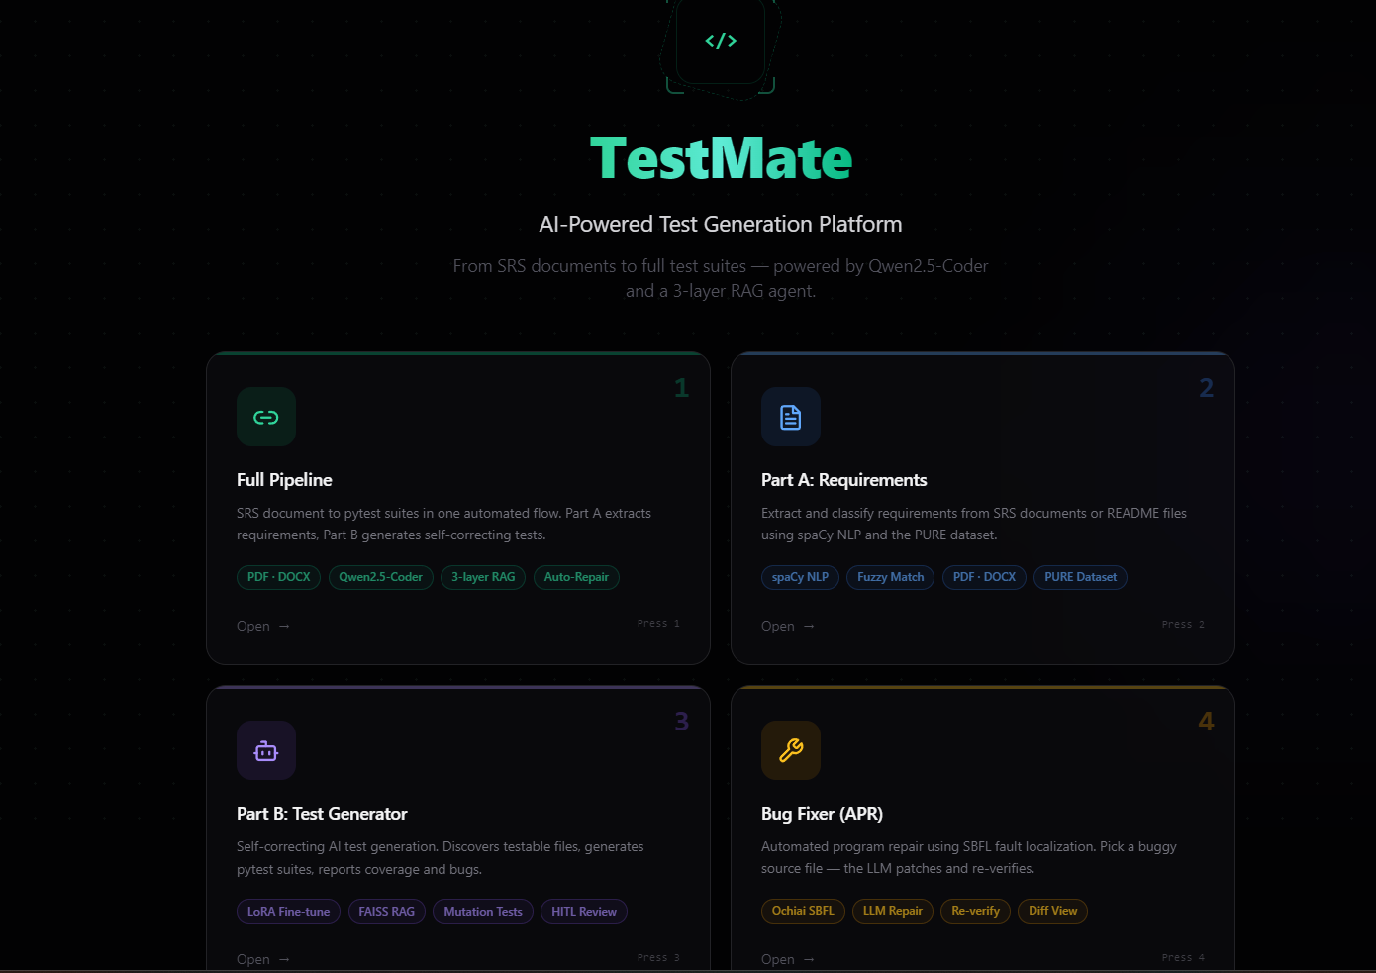
Figure 5.1:TestMate home screen with the four workflow entry cards
5.4 Workflow Walkthrough
5.4.1 Requirement Extraction (Part A)
PartAbeginswiththeinputpanelshowninFigure5.2.Heretheusermayoptionallyup-load an SRS document (in PDF or DOCX form), optionally provide README or free-text descriptiontext,andpointTestMateattherepositorytobetestedbyapath,togetherwith the Discover Files action that enumerates the testable source files.A mode selector lets the userchoosebetweentheSRSPipeline,theREADMEExtractor,orboth,andasimilarity-threshold control governs how strictly sentences are matched.
40

CHAPTER 5.SYSTEM TESTING
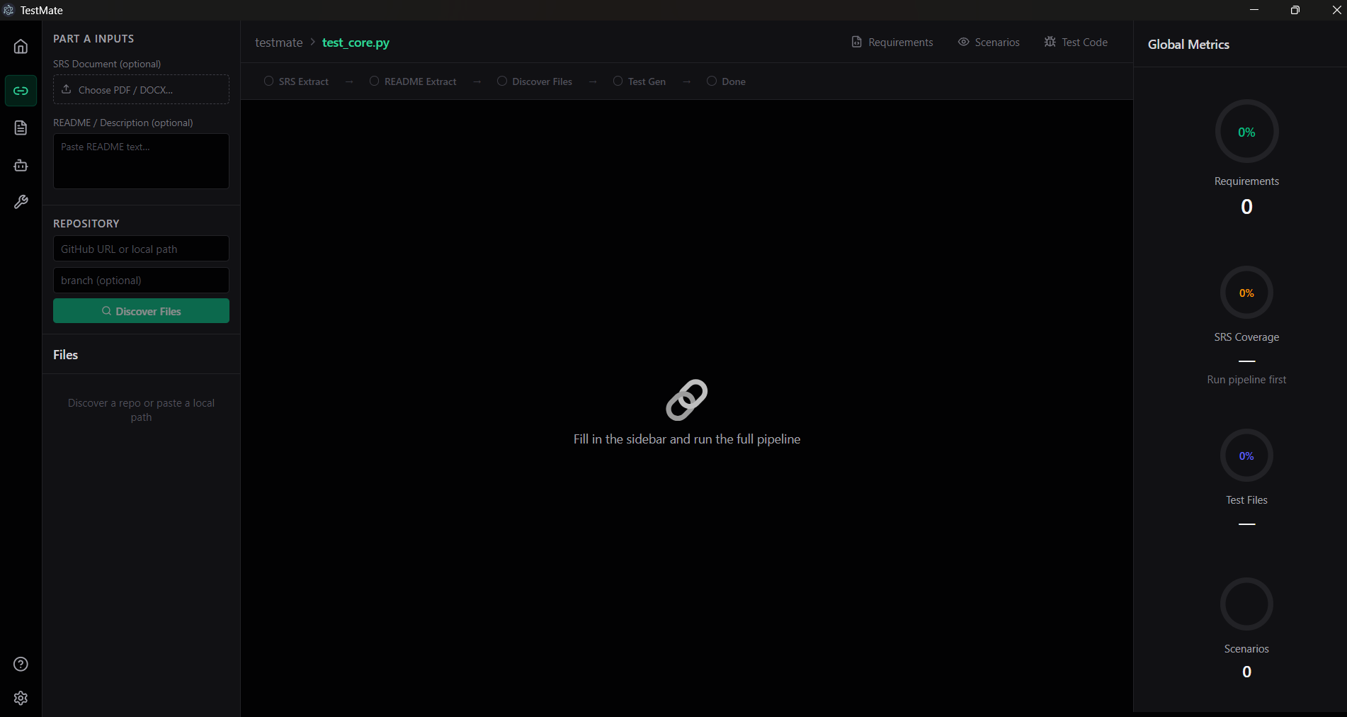
Figure 5.2:Part A input panel with the mode selector and similarity threshold
Figure5.3showsacompletedPartArunonarealSRSPDF.Thepipelinestagesare all marked complete — Read Document, Segment, Align, Scenarios, and Done — and each extracted item is classified as either a requirement (REQ) or a non-requirement, with a per-item match percentage.The run reports 128 Requirements and 201 Non-Requirements, for 329totalitemsprocessed,ata44%MatchScore.ThisdemonstratesPartAsuccessfully extracting and classifying requirements from a genuine specification document rather than a contrived example.
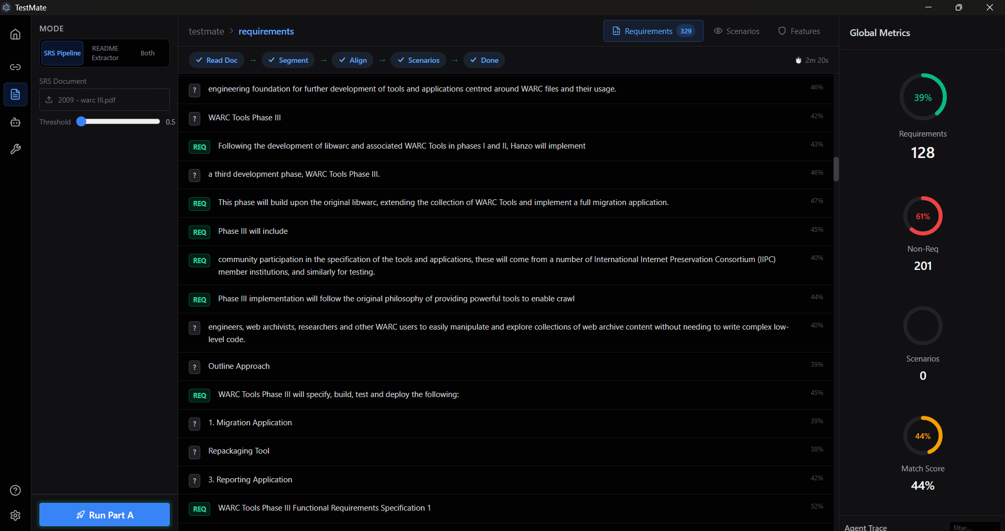
Figure5.3:CompletedPartArun:329itemsclassifiedasREQvs.non-requirementona real SRS PDF
41

CHAPTER 5.SYSTEM TESTING
5.4.2 | Test Generation (Part B)
Figure5.4showsacompletedPartBrun.Thepipelinestagesareallmarkedcomplete—Discover Files, Load Model, Generate Tests, Evaluate, and Done — and the Generated Test Code panel displays a produced pytest test.The file under test is HumanEvalFix_053.py, and the Global Metrics for this run report 100% coverage and a 100% mutation score.These figures show the generate–run–fix loop producing a test that both fully covers the file under testandkillseveryinjectedmutant,withtheBESgateandthemutationcheckbehindthe reported numbers.

Figure 5.4:Completed Part B test-generation run with the generated pytest test and metrics
5.4.3 Bug Detection
Figure5.5showstheZero-DayBugsview,theinterfacethroughwhichTestMatesurfaces the defects that its generated tests expose.The accompanying metrics summarise a run along four axes — Coverage,Mutation Score,Bugs Detected,and Stale Tests.The figure shows thebug-detectioninterfaceinitsstatepriortoadetectionrun;inoperationitisherethat theconfidence-scoredoraclesdescribedinChapter4classifythefailuresproducedbythe generated tests and report how many bugs were detected and whether any existing tests have become stale.
5.4.4 Automated Program Repair (Part C)
The final and strongest demonstration is automated program repair.Figure 5.6 shows a com-pletedrepair.Thepipelinestagesareallmarkedcomplete—DiscoverFiles,RunTests, SBFLLocalize,LLMRepair,Re-test,andDone—andtheviewreports“Bugfixed!”,
42

CHAPTER 5.SYSTEM TESTING
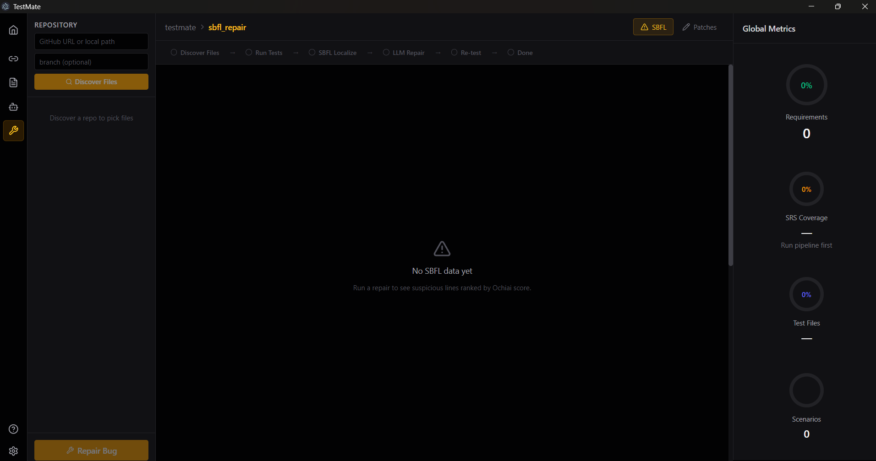
Figure 5.5:The Zero-Day Bugs view and bug-detection metrics interface
achievedinasingleattemptin69.6seconds,with“Alltestspassed”aftertherepair.The spectrum-based fault localiser identified five suspicious locations, and one patch was applied. The file under repair is a real source file, core_utils.py, containing a discount-calculation bug.ThisillustratesthefullSBFL→LLM-repair→re-testflowoperatingonagenuine defect.
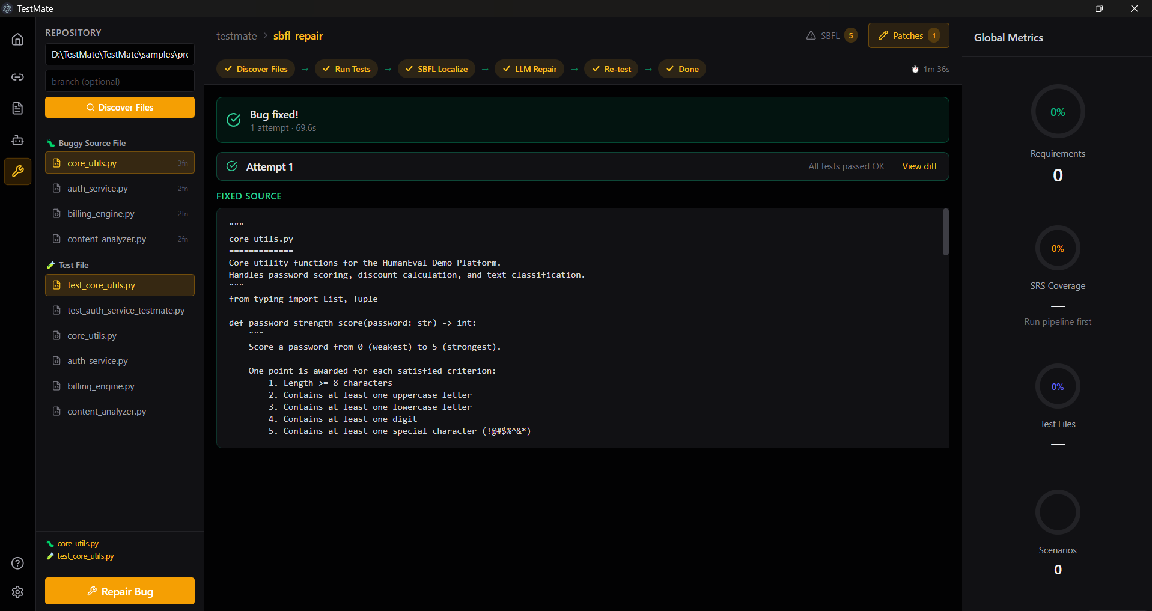
Figure 5.6:Completed Part C repair:bug fixed in one attempt, all tests passing after the patch
Figure 5.7 shows the diff view of the same repair, presenting the actual before-and-after changewithremovedlinesinredandaddedlinesingreen,wherethebuggydiscountrate was corrected.This is a genuine logic fix, not a cosmetic edit, and it is validated by the test suite passing after the patch is applied.
43

CHAPTER 5.SYSTEM TESTING
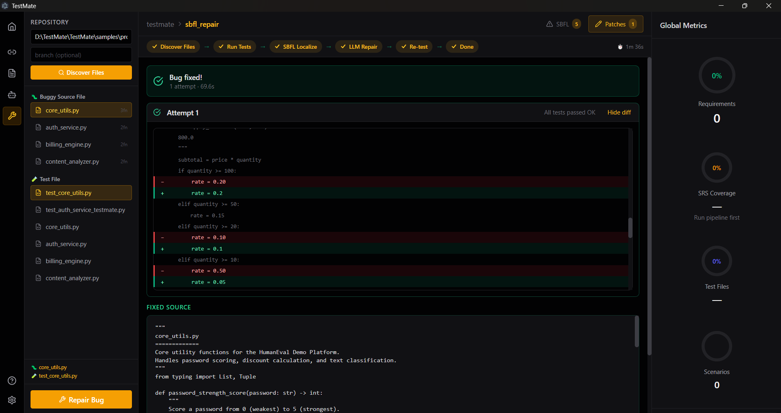
Figure5.7:PartCdiffview:thecorrecteddiscount-calculationlogic(redremoved,green added)
5.5 Discussion
ThewalkthroughshowsthecompleteTestMatepipelineoperatingasdesignedonrealin-puts:PartAclassifies329itemsfromagenuinespecificationdocument,PartBgenerates a test reaching 100% coverage and a 100% mutation score, and Part C localises and repairs a real discount-calculation bug,verified by the tests passing afterwards.The coverage and mutation-scoremetricssurfacedbytheinterfaceareconsistentwith,andcorroborate,the quantitativeresultsreportedinChapter4,whiletherepairdemonstrationconfirmsthatthe SBFL-guided repair loop works end to end within the desktop application.
44

Chapter 6
Conclusion and Future Work
6.1 Conclusion
This project set out to address a persistent and costly problem in software engineering:writ-ing tests that genuinely exercise a program, and repairing the defects those tests reveal, are slow, repetitive, and inconsistent activities whose quality depends heavily on the individual developer.The artificial-intelligence assistants that could help with these tasks typically rely on paid cloud APIs, which raises concerns over cost, latency, and the privacy of proprietary source code.TestMate was conceived to close this gap by automating the software-quality lifecycle — from requirements, through generated tests and bug detection, to automated re-pair — entirely on the developer’s own machine.
Tothisend,TestMatewasbuiltasacross-platformElectrondesktopapplicationthat wraps a fully local AI pipeline.A single open-weights model, Qwen2.5-Coder-7B-Instruct, ishostedlocallyin4-bitquantisationandspecialisedwithlightweightLoRAsupervised fine-tuning;itisaugmentedwithathree-layerRetrieval-AugmentedGenerationpipeline thatgroundsgenerationinexternaltestingknowledge,thestructureofthecodeundertest, and the system’s own accumulated experience.Test generation runs inside a self-correcting generate–run–fix loop gated by the Bug Exposure Score, and automated repair is driven by spectrum-based fault localisation followed by AST-safe patching.No part of the system de-pends on a paid or remote inference service.
Evaluated on contamination-free public benchmarks, the system shows substantial gains over the un-tuned base model.On HumanEval, pass@1 rises from 33.5% to 60.4% and line coveragefrom34.10%to67.64%;onTestEvalthesystemreaches93.8%linecoveragein suitemode;andontheHumanEvalFixbenchmarkof164bugstheautomated-repairsuc-cess rate improves from 67.68% to 91.46%.Because the reported model is the MBPP-only configuration decontaminated against the evaluation sets, these gains can be read as genuine generalisation rather than memorisation.
The central contribution of the work is the Bug Exposure Score (BES): a five-dimension, quantitative quality gate that estimates a test’s fault-exposing power rather than its mere struc-tural coverage, and that rejects superficially high-coverage tests which assert nothing mean-ingful.TakentogetherwiththeLoRAfine-tuning,theretrievalpipeline,andtheiterative loops,BESsupportstheproject’scentralthesis—thatasmall,locally-runmodelcanbe
45

CHAPTER 6.CONCLUSION AND FUTURE WORK
made competitive through careful engineering rather than sheer scale — while keeping the entire workflow free to run, private, and offline.
6.2 Advantages and Disadvantages
Advantages. TestMate’s most distinctive strength is that it operates entirely locally and of-fline.Inference requires no paid cloud API, so the tool is free to run and incurs no per-request cost, and because source code is not transmitted to external servers, it preserves the privacy of proprietary code.It is also unusually broad in scope for a single tool:rather than address-ingonlyoneactivity,itintegratesrequirementextraction,testgeneration,bugdetection, and automated program repair into one end-to-end desktop application.The Bug Exposure Score gives the system a principled, quantitative notion of test quality, so that accepted tests havegenuinefault-detectionpotentialinsteadofmerelyhighcoverage.Theevaluationis contamination-free, which lends credibility to the reported gains, and the use of 4-bit quanti-sation means the whole pipeline runs on a single consumer-grade GPU rather than requiring datacentre hardware.
DisadvantagesandLimitations. Thesestrengthscomewithrealconstraints.Themost fundamental is the GPU memory coexistence limitation:the requirement-extraction model andthemaincodemodelcannotberesidentatthesametime,whichforcesthesystemto loadamodel,runastage,andfreeitsmemorybeforethenextstage—andeventorun the lighter extraction step in an isolated subprocess so that memory is reliably reclaimed —adding latency between stages.The system also depends on a capable local GPU (broadly in the range of 6–8 GB of VRAM for the 4-bit model); without one it cannot run.Its scope isPython-centric,targetingPythonrepositoriesandthepytestframeworkratherthanarbi-trary languages.The reported model is fine-tuned on only a modest, decontaminated MBPP-derived training set for a single epoch, and its strongest test-generation coverage, while high for an open 7-billion-parameter model, still trails the largest proprietary models (for exam-ple, the 98.7% TestEval line coverage reported for GPT-4o).Finally, the system is not fully self-contained as distributed:the model weights and the retrieval memory are supplied sep-arately rather than bundled, some model paths in the code are machine-specific and must be made portable, and the requirement-extraction component relies on code maintained outside the main repository.
6.3 Future Work
The project opens several concrete and credible directions for further development:
•Trainonthelargerdatamixturewithfulldecontamination.Movebeyondthe
46

CHAPTER 6.CONCLUSION AND FUTURE WORK
MBPP-only model to the explored SWE-bench+Magicoder+MBPP mixture, applying thorough decontamination against all evaluation sets so that the larger training signal can be used without compromising contamination-free reporting.
•Extend language support beyond Python.Generalise the static analysis, test runner, and repair patching to additional languages and testing frameworks so that the tool is no longer limited to Python and pytest.
•Conductdeeperablationstudies.Quantifytheindividualcontributionofeachre-trieval layer, the self-correcting loop, the planning step, and the BES gate, completing the per-component analysis that is only partially reported here.
•Integrate with IDEs and CI pipelines.Embed TestMate into the developer’s editor andintocontinuous-integrationworkflowssothattestsandrepairscanbegenerated and validated automatically as code changes.
•Reduce VRAM pressure.Investigate smarter model scheduling, lighter or more ag-gressively compressed models, and improved memory release to relax the coexistence constraint and shorten the latency between pipeline stages.
•Expand the Bug Exposure Score.Add further fault-exposure dimensions and refine the existing ones, and explore calibrating the gate’s thresholds against measured bug-detection outcomes.
•Improve portability and packaging.Remove machine-specific paths and bundle (or automatically fetch) the model weights and retrieval memory so that the application is self-contained and runs unmodified on a new machine.
47

Tools
[Tools used in the project.If you can, classify them into hardware and software tools.]
48

References
[1] Mark Chen et al. Evaluating large language models trained on code. arXiv:2107.03374.
2021.
[2] Baptiste Rozière et al. Code Llama: Open foundation models for code. arXiv:2308.12950.
2023.
[3] QihaoZhuetal.DeepSeek-Coder:Whenthelargelanguagemodelmeetsprogram-
ming. arXiv:2401.14196. 2024.
[4] Binyuan Hui et al. Qwen2.5-Coder technical report. arXiv:2409.12186. 2024.
[5] Edward J. Hu et al. “LoRA: Low-rank adaptation of large language models.” In: ICLR
2022. 2021.
[6] Sourab Mangrulkar et al. PEFT: State-of-the-art parameter-efficient fine-tuning. GitHub:
huggingface/peft. 2022.
[7] Tim Dettmers et al. “QLoRA: Efficient finetuning of quantized LLMs.” In: NeurIPS.
2023.
[8] Jacob Austin et al. Program synthesis with large language models. arXiv:2108.07732.
2021.
[9] PatrickLewisetal.“Retrieval-augmentedgenerationforknowledge-intensiveNLP
tasks.” In: NeurIPS. 2020.
[10] Yang Liu et al. KGCompass: Knowledge graph-based code navigation for RAG. arXiv:2501.00000.
2025.
[11] Nils Reimers and Iryna Gurevych. “Sentence-BERT: Sentence embeddings using Siamese
BERT-networks.” In: EMNLP. 2019.
[12] Jeff Johnson, Matthijs Douze, and Hervé Jégou. “Billion-scale similarity search with
GPUs.” In: IEEE Transactions on Big Data (2019).
[13] Stephen E. Robertson et al. “Okapi at TREC-3.” In: TREC. 1994.
[14] Carlos Pacheco et al. “Feedback-directed random test generation.” In: ICSE. 2007.
[15] GordonFraserandAndreaArcuri.“EvoSuite:Automatictestsuitegenerationfor
object-oriented software.” In: ESEC/FSE. 2011.
[16] StephanLukasczyketal.“Pynguin:AutomatedunittestgenerationforPython.”In:
ICSE Demo Track. 2022.
49

References
[17] | Z.Chenetal.ChatUniTest:AChatGPT-basedautomatedunittestgenerationtool.
arXiv:2305.04764. 2023.
[18] Michele Tufano et al. “AthenaTest: Towards automated unit test generation using pre- trained transformers.” In: ASE. 2022.
[19] CarolineLemieuxetal.“CodaMosa:Escapingcoverageplateausintestgeneration with pre-trained large language models.” In: ICSE. 2023.
[20] ZhuoWangetal.TestEval:Benchmarkinglargelanguagemodelsforcodetesting. arXiv:2406.04531. 2024.
[21] Claire Le Goues et al. “GenProg: A generic method for automatic software repair.” In: IEEE Transactions on Software Engineering (2012).
[22] YuhuaQietal.“Thestrengthofrandomsearchonautomatedprogramrepair.”In: ICSE. 2014.
[23] Dongsun Kim et al. “Automatic patch generation learned from human-written patches.” In: ICSE. 2013.
[24] MingWenetal.“Context-awarepatchgenerationforbetterautomatedprogramre- pair.” In: ICSE. 2018.
[25] Chunqiu Steven Xia, Yifeng Ding, and Lingming Zhang. ChatRepair: Conversational automated program repair. arXiv:2404.00566. 2024.
[26] Carlos E. Jimenez et al. “SWE-bench: Can language models resolve real-world GitHub issues?” In: ICLR. 2024.
[27] Rui Abreu, Peter Zoeteweij, and Arjan J. C. van Gemund. “On the accuracy of spectrum- based fault localization.” In: TAICPART-MUTATION. 2007, pp. 89–98.
[28] Fabiano Dalpiaz et al. “PURE: A dataset of public requirements documents.” In: REFSQ Workshops. 2019.
[29] Yunfan Gao et al. Retrieval-augmented generation for large language models: A sur- vey. arXiv:2312.10997. 2023.
[30] Wayne Xin Zhao et al. A survey of large language models. arXiv:2303.18223. 2024.
50

